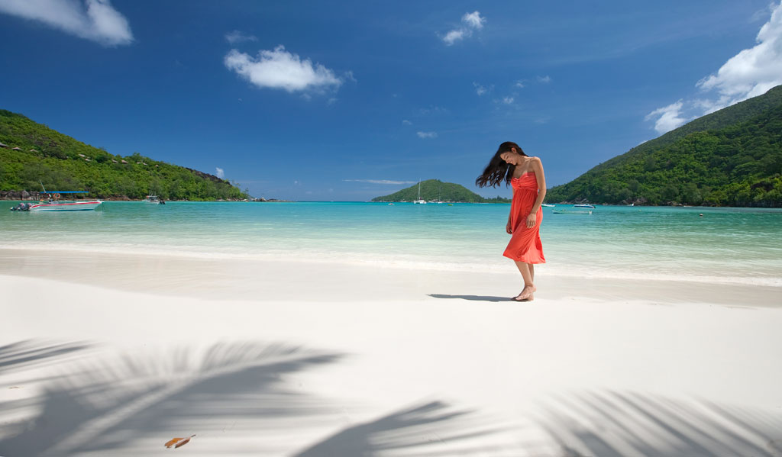
Seychelles
Constance Hotel Experience

Ephelia Resort & Lemuria Resort
^{www.epheliaresort.com}

6 Nights Package
Validity: 16Jul, 2012 ~ 30Apr, 2013

Package Inclusion 套票包括:

- Roundtrip economy class air ticket HKG/DXB/SEZ/DXB/HKG on Emirates Airline.
阿聯酋國際航空往返香港及塞舌爾經濟客位機票乙張 。
- Roundtrip economy class air ticket SEZ/PRI/SEZ on Air Seychelles
塞舌爾航空往返馬埃島及普拉蘭島經濟客位機票乙張 。
- 6 night’s accommodation with daily breakfast & dinner.6晚酒店住宿連早餐及晚餐。
- Roundtrip transfer between airport & hotel 機場至酒店來回接送。
- 0.15% tic Levy. 0.15%旅遊業議會印花稅。
- Travel Insurance (Coverage of personal accident up to HK$100,000).
旅遊保險 (人身意外最高賠償 HK$100,000)。

** Special Offer **
Junior Suite : Less HK1000 (per person)
Validity : 01Aug-01Sep2012 / 21Oct-22Dec2012 /
07Jan-21Mar2013
(Last departure from Hotel)

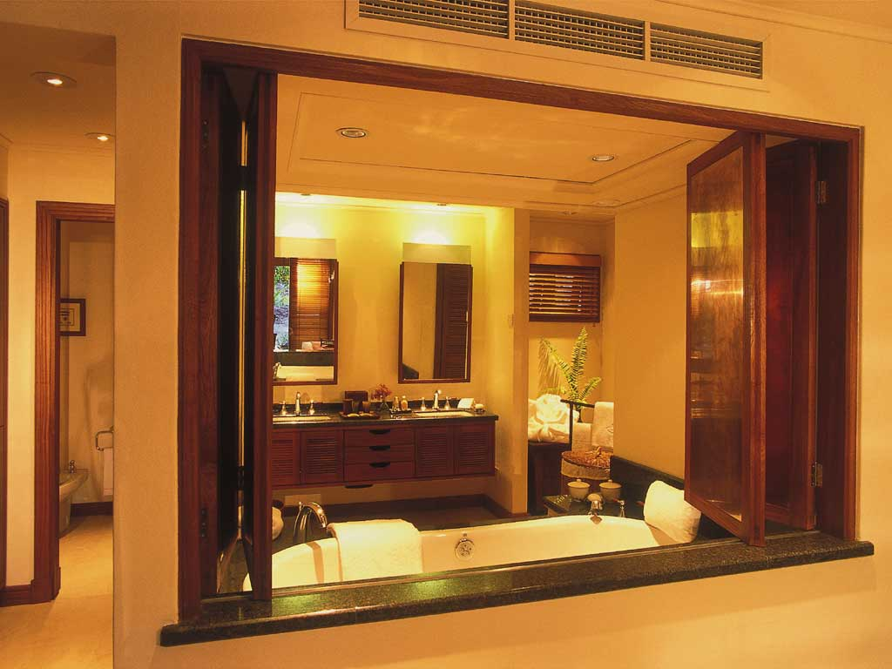
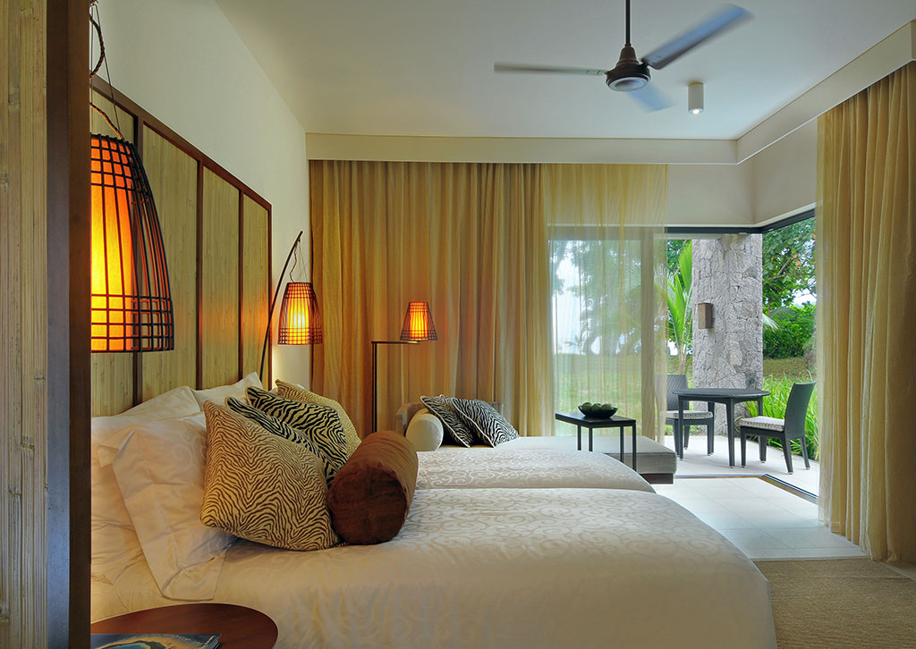
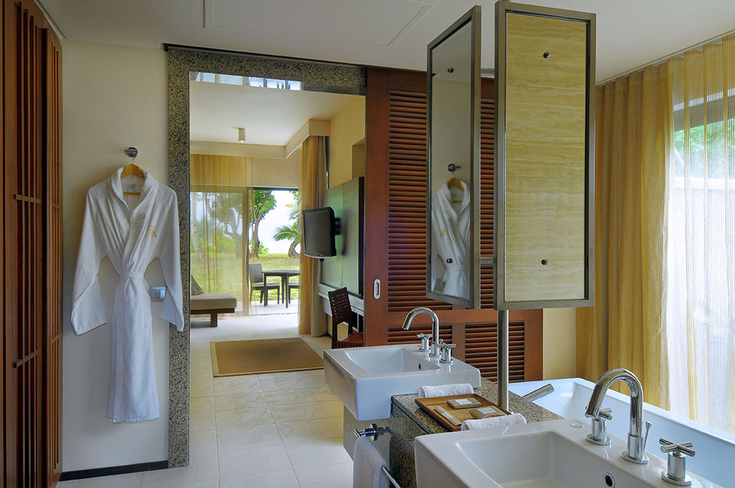
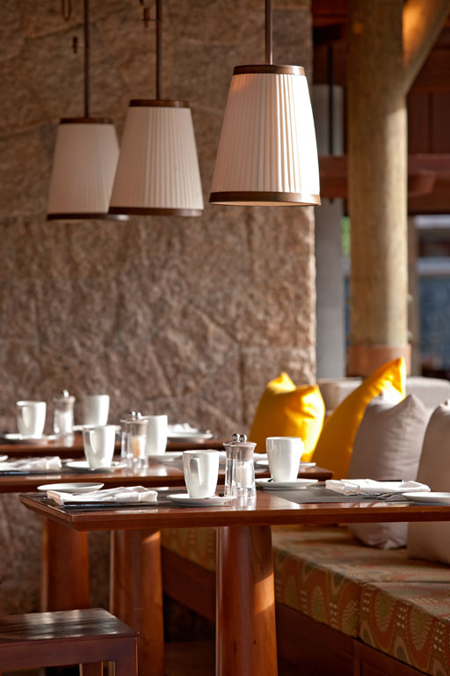
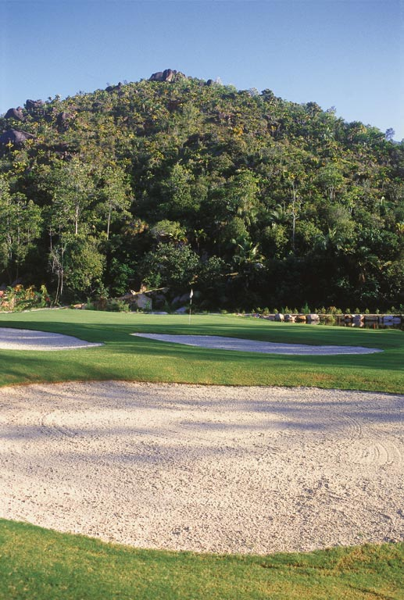
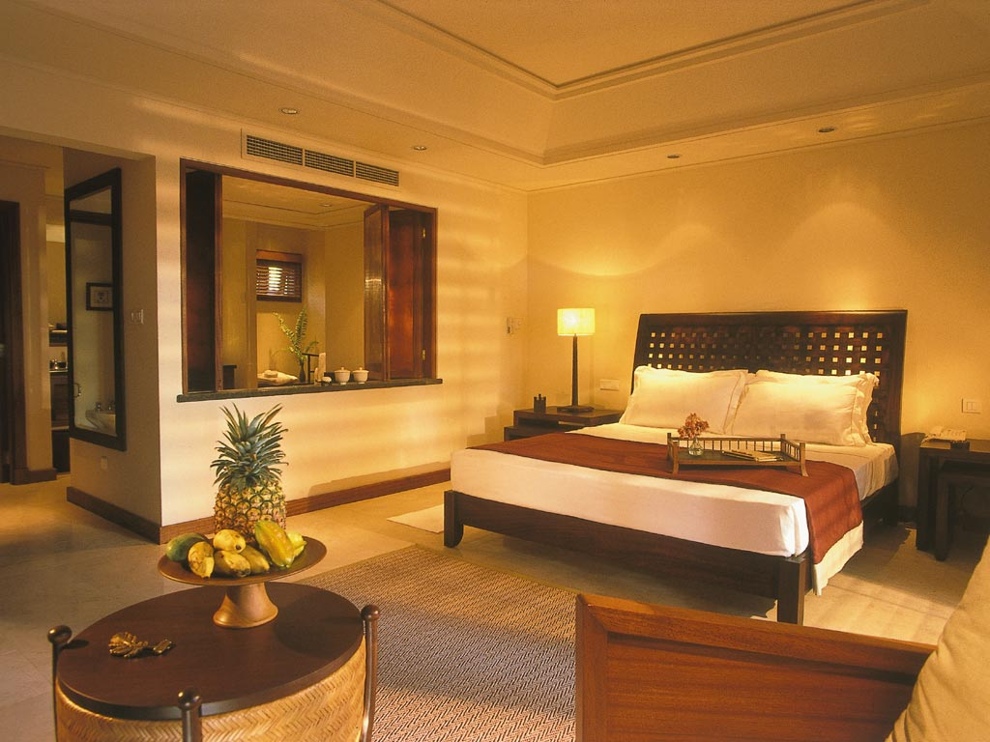

Issued date: 11Jul,2012
Hotel  酒店種類  Room Type  房間種類 |  |  | Hotel Stay  酒店住宿 | Adult 成人 |  |  | Extension Night with Breakfast  包早餐延長住宿  Per night (毎晩計)
 |  |  | Hotel Stay  酒店住宿 | Twin  雙人房 |  | Single  單人房 | Twin/  雙人房  (Ephelia / Lemuria) | Single  單人房  (Ephelia / Lemuria)
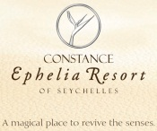Ephelia Resort  (3nights)  Junior Suite  (62sqm, Max 2Adult +1Child)  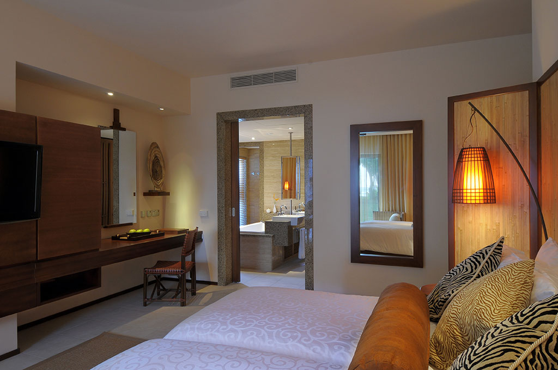 | 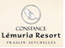Lemuria Resort  (3nights)  Junior Suite  (52sqm, Max 2Adult) |  | 01Jul12 – 30Sep12  01Dec12 – 22Dec12 | 28,890 |  | 38,990 | 5,100 / 6,500 | 3,900 / 4,960
 |  |  | 01Oct12 – 30Nov12  07Jan13 – 30Apr13 | 31,990 |  | 43,390 | 5,650 / 8,000 | 4,300 / 6,100

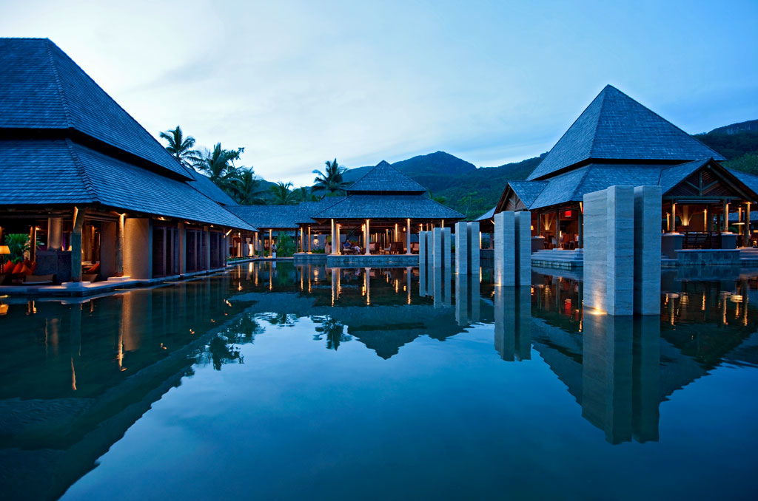
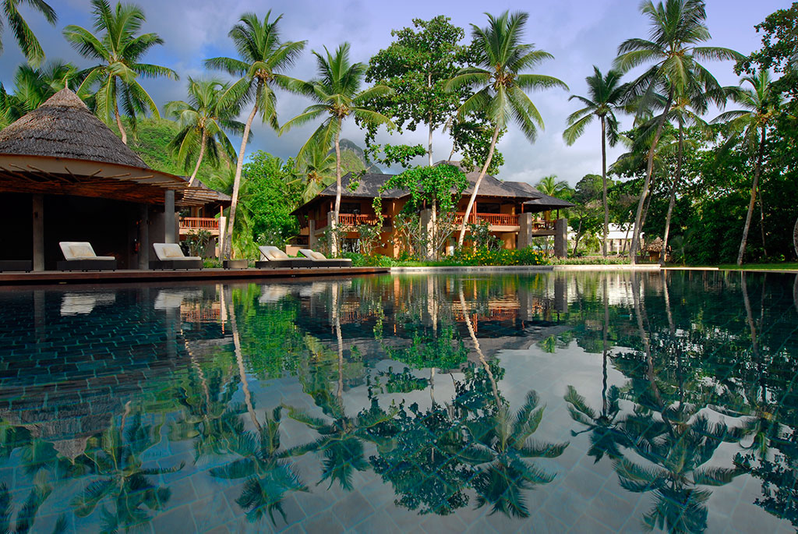
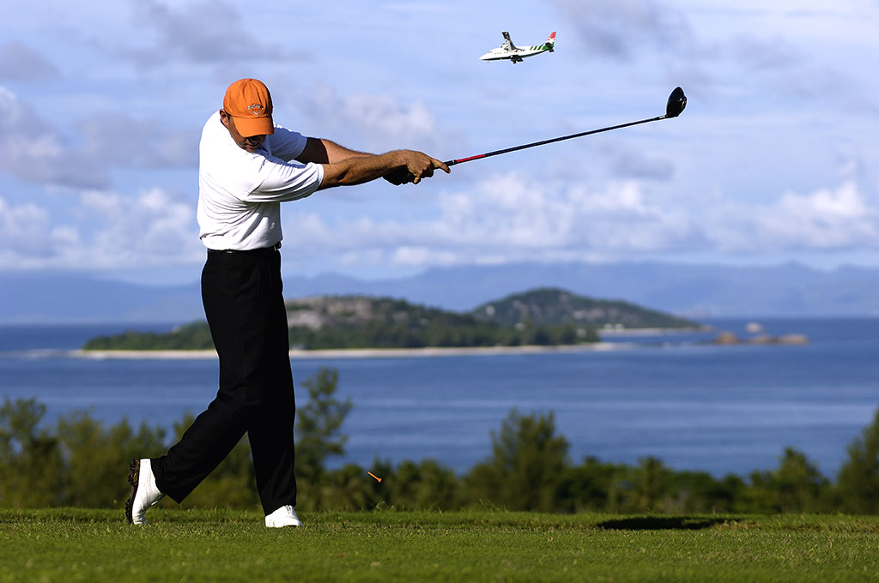
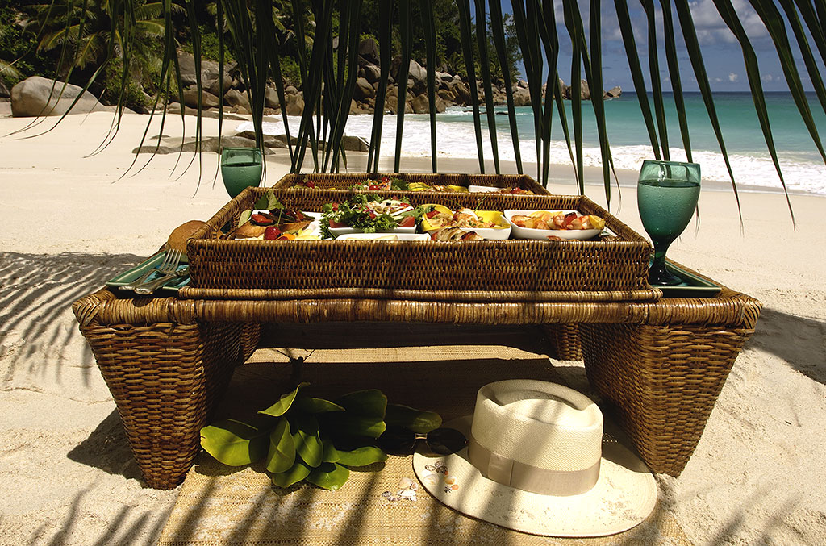

Air fare surcharge details 機票附加費詳情 |  |  | per person in HK$/每位收費以港幣計算
Travel Period  出發日期 | Booking Class  訂位編號 | Ticket Validity  機票有效期 |  | Adult  成人 | Child  小童
Economy Class 經濟客位
25Aug2012 – 07Feb2013  15Feb2013 – 30Apr2012 | B | 3days / 4mths |  | Nil | Nil
25Aug2012 – 07Feb2013  15Feb2013 – 30Apr2012 | M |  |  | 860 | 650
25Aug2012 – 07Feb2013  15Feb2013 – 30Apr2012 | W |  |  | 1710 | 1290
25Aug2012 – 07Feb2013  15Feb2013 – 30Apr2012 | R |  |  | 2600 | 1950
13Jul2012 – 24Aug2012  08Feb2013 – 14Feb2013 | B | 3days / 4mths |  | 1250 | 950
13Jul2012 – 24Aug2012  08Feb2013 – 14Feb2013 | M |  |  | 2100 | 1600
13Jul2012 – 24Aug2012  08Feb2013 – 14Feb2013 | W |  |  | 2950 | 2250
13Jul2012 – 24Aug2012  08Feb2013 – 14Feb2013 | R |  |  | 3800 | 2900
Package Inclusion 套票包括:
- Roundtrip economy class air ticket HKG/DXB/SEZ/DXB/HKG on Emirates Airline.
阿聯酋國際航空往返香港及塞舌爾經濟客位機票乙張 。
- Roundtrip economy class air ticket SEZ/PRI/SEZ on Air Seychelles by PTS
塞舌爾航空往返馬埃島及普拉蘭島經濟客位機票乙張 。
- 6 night’s accommodation with daily breakfast & dinner. 6晚酒店住宿連早餐及晚餐。
- Roundtrip transfer between airport & hotel 機場至酒店來回接送。
- 0.15% tic Levy. 0.15%旅遊業議會印花稅。
- Travel Insurance (Coverage of personal accident up to HK$100,000). 旅遊保險 (人身意外最高賠償 HK$100,000)。
Terms & Conditions 條款及細則:
- Prices are quoted per person in Hong Kong Dollars and subject to change without prior notice.
費用以港幣及個人計算，費用如有調整，恕不另行通知。
- Flights and room confirmation are subject to availability. 所有預訂須視乎酒店及機位情況方能確定。
- Hotel special offer & family offer should a dispute arise, hotel reserves the right to arbitrate the final decision.
酒店之優惠項目，均由各酒店保留最終決定權。
- Package is non-endorsable, non re-routable and non-refundable. 旅遊套餐在任何情況下都不能更改，轉讓或退還款項。
- Reservation must be made at least 14 working days prior to departure. 所有訂位手續須於出發前不少於十四個工作天內辦理。
- For reservation made within 7 working days prior to departure, a non-refundable full payment is required.
凡於出發前14個工作天內辦理預訂手續，須繳付所有款項, 已付之費用概不退還。
- Departure taxes, Hong Kong airport security charge, airlines insurance surcharge, fuel surcharge and travel agent service fees are not included.
費用不包括各地機場離境稅，香港機場保安稅，保險附加費，燃油附加費及旅行社服務費。

