Seychelles
Constance Ephelia Resort ^{www.epheliaresort.com}
4 Nights Package
Validity: 16Jul, 2012 ~ 30Apr, 2013

Package Inclusion 套票包括:

- Roundtrip economy class air ticket HKG/DXB/SEZ/DXB/HKG by Emirates Airline.
阿聯酋國際航空往返香港及塞舌爾經濟客位機票乙張 。
- 4 night’s accommodation with daily breakfast&Dinner.4晚酒店住宿連早餐及晚餐。
- Roundtrip transfer between airport & resort 酒店來回機場接送。
- 0.15% tic Levy. 0.15%旅遊業議會印花稅。
- Travel Insurance (Coverage of personal accident up to HK$100,000).
旅遊保險 (人身意外最高賠償 HK$100,000)。

** Special Offer **
Junior Suite / Senior Suite : Less HK1200 (per person)
Beach Villa ( 1 bedroom ) : Less HK2200 (per person)
Validity : 16Jul ~ 01Aug 2012 / 01Sep – 20Oct 2012
(Last departure from Hotel & NOT combinable with ANY offer)
** Special Offer **
Stay 7 nights pay 6 night
Validity : 16Jul ~ 01Aug 2012 / 01Sep – 20Oct 2012
(Last departure from Hotel)

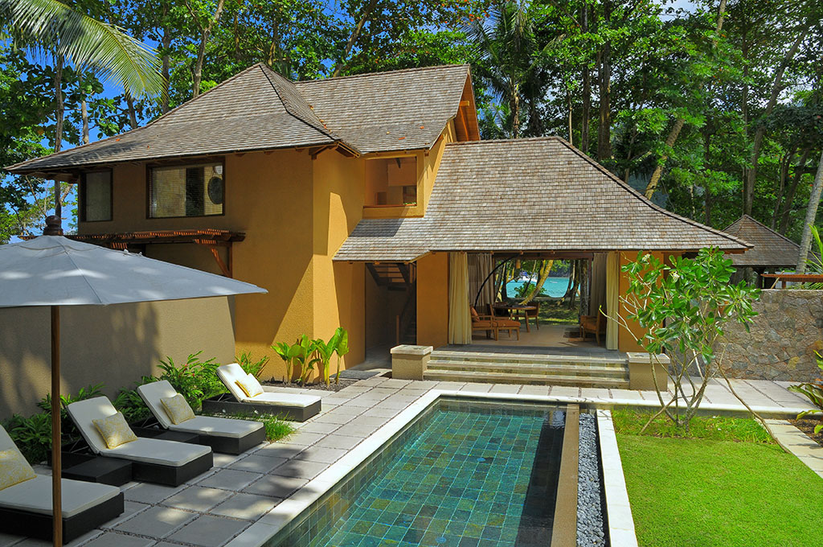
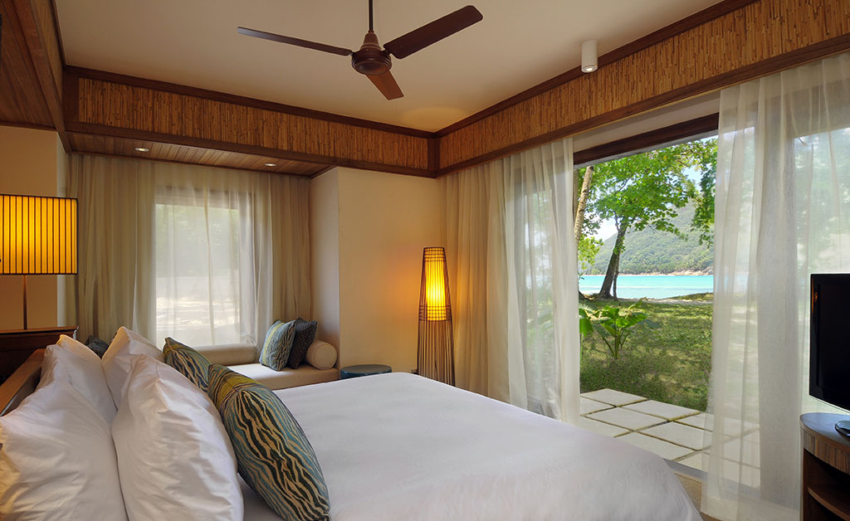
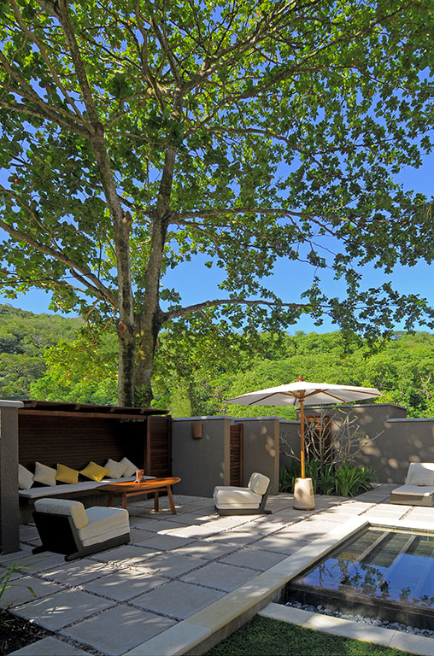
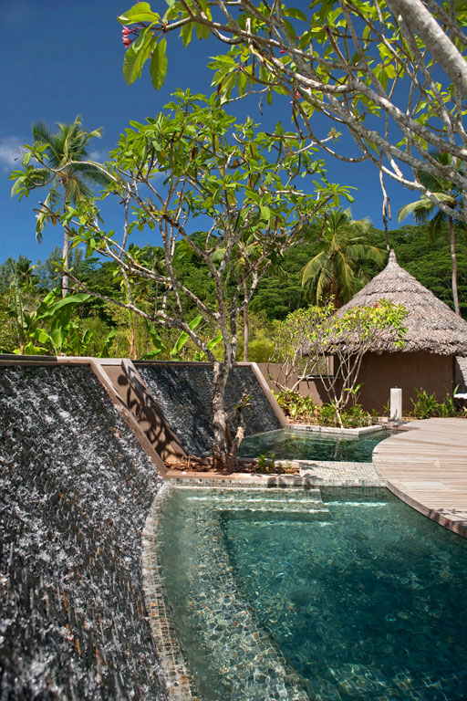
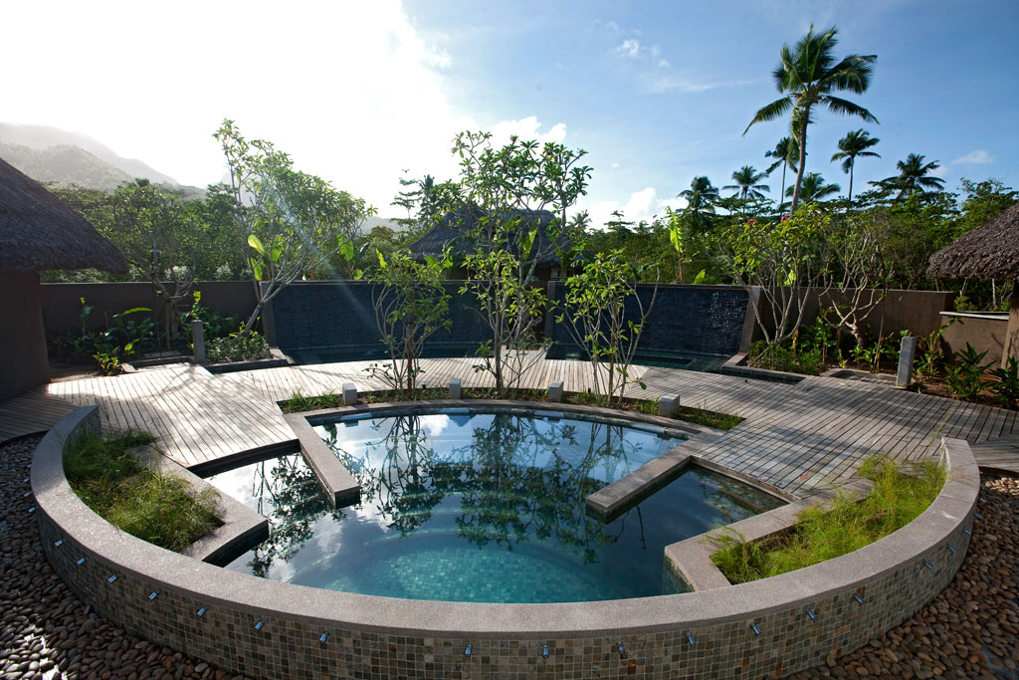
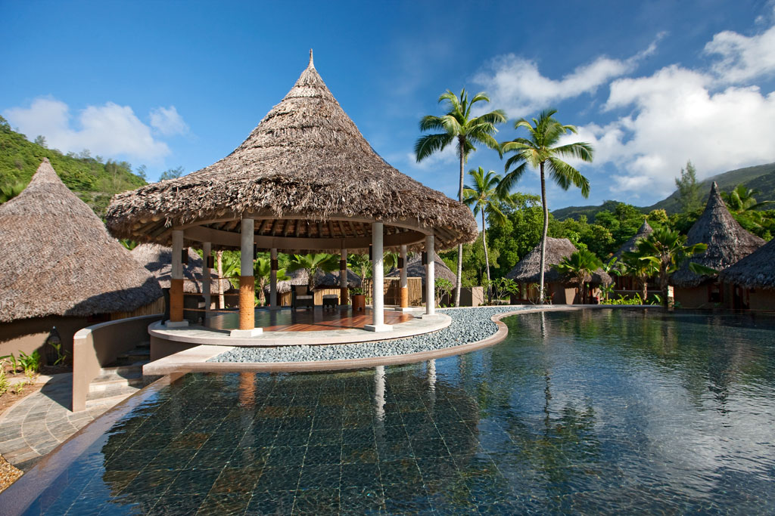

Issued date: 11Jul,2012
Room Type  房間種類 | Hotel Stay  酒店住宿 | Adult 成人 |  |  | Extension Night with Breakfast  包早餐延長住宿  Per night (毎晩計)
Room Type  房間種類 | Hotel Stay  酒店住宿 | Twin  雙人房 |  | Single  單人房 | Twin/  雙人房 | Single  單人房
Junior Suite  (62sqm, Max 2Adult +1Child) | 16Jul ~ 30Sep,12  01Dec ~ 22Dec,12 | 16,890 |  | 21,890 | 5,100 | 3,900
Junior Suite  (62sqm, Max 2Adult +1Child) | 01Oct ~ 30Nov,12  07Jan ~ 30Apr,13 | 17,990 |  | 23,490 | 5,650 | 4,300
Senior Suite  (80sqm, Max 2Adult +1Child) | 16Jul ~ 30Sep,12  01Dec ~ 22Dec,12 | 19,290 |  | 25,490 | 6,300 | 4,760
Senior Suite  (80sqm, Max 2Adult +1Child) | 01Oct ~ 30Nov,12  07Jan ~ 30Apr,13 | 20,590 |  | 27,490 | 6,970 | 5,300
Beach Villa (1 Bedroom)  (185sqm, Max 2Adult) | 16Jul ~ 30Sep,12  01Dec ~ 22Dec,12 | 29,790 |  | 50,090 | 11,600 | 10,950
Beach Villa (1 Bedroom)  (185sqm, Max 2Adult) | 01Oct ~ 30Nov,12  07Jan ~ 30Apr,13 | 32,490 |  | 55,490 | 13,000 | 12,300

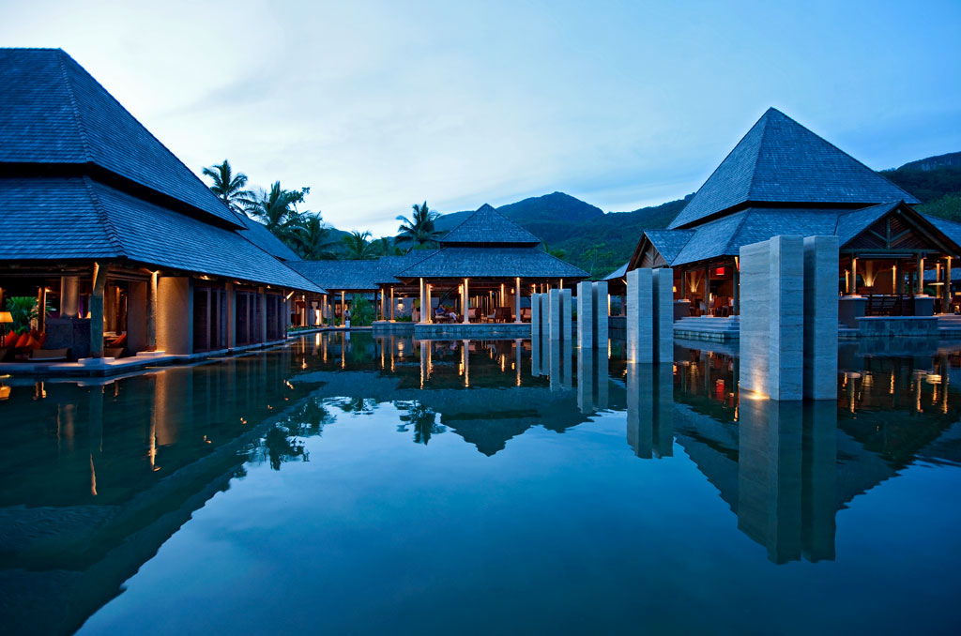
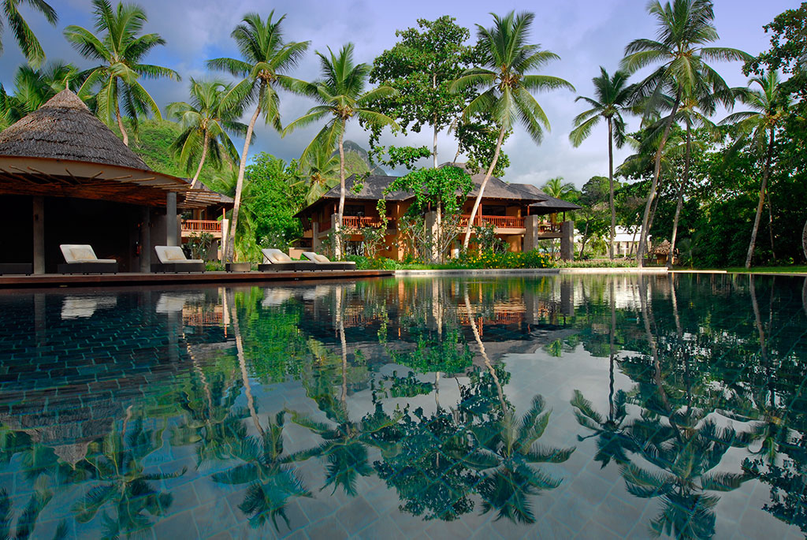



Air fare surcharge details 機票附加費詳情 |  |  | per person in HK$/每位收費以港幣計算
Travel Period  出發日期 | Booking Class  訂位編號 | Ticket Validity  機票有效期 |  | Adult  成人 | Child  小童
Economy Class 經濟客位
Package Inclusion 套票包括:
- Roundtrip economy class air ticket HKG/DXB/SEZ/DXB/HKG by Emirates Airline.
阿聯酋國際航空往返香港及塞舌爾經濟客位機票乙張 。
- 4 night’s accommodation with daily breakfast & dinner.4晚酒店住宿連早餐及晚餐。
- Roundtrip transfer between airport & resort 酒店來回機場接送。
- 0.15% tic Levy. 0.15%旅遊業議會印花稅。
- Travel Insurance (Coverage of personal accident up to HK$100,000). 旅遊保險 (人身意外最高賠償 HK$100,000)。
Terms & Conditions 條款及細則:
- Prices are quoted per person in Hong Kong Dollars and subject to change without prior notice.
費用以港幣及個人計算，費用如有調整，恕不另行通知。
- Flights and room confirmation are subject to availability. 所有預訂須視乎酒店及機位情況方能確定。
- Hotel special offer & family offer should a dispute arise, hotel reserves the right to arbitrate the final decision.
酒店之優惠項目，均由各酒店保留最終決定權。
- Package is non-endorsable, non re-routable and non-refundable. 旅遊套餐在任何情況下都不能更改，轉讓或退還款項。
- Reservation must be made at least 14 working days prior to departure. 所有訂位手續須於出發前不少於十四個工作天內辦理。
- For reservation made within 7 working days prior to departure, a non-refundable full payment is required.
凡於出發前14個工作天內辦理預訂手續，須繳付所有款項, 已付之費用概不退還。
- Departure taxes, Hong Kong airport security charge, airlines insurance surcharge, fuel surcharge and travel agent service fees are not included.
費用不包括各地機場離境稅，香港機場保安稅，保險附加費，燃油附加費及旅行社服務費。
25Aug2012 – 07Feb2013  15Feb2013 – 30Apr2012 | B | 3days / 4mths |  | Nil | Nil
25Aug2012 – 07Feb2013  15Feb2013 – 30Apr2012 | M |  |  | 860 | 650
25Aug2012 – 07Feb2013  15Feb2013 – 30Apr2012 | W |  |  | 1710 | 1290
25Aug2012 – 07Feb2013  15Feb2013 – 30Apr2012 | R |  |  | 2600 | 1950
13Jul2012 – 24Aug2012  08Feb2013 – 14Feb2013 | B | 3days / 4mths |  | 1250 | 950
13Jul2012 – 24Aug2012  08Feb2013 – 14Feb2013 | M |  |  | 2100 | 1600
13Jul2012 – 24Aug2012  08Feb2013 – 14Feb2013 | W |  |  | 2950 | 2250
13Jul2012 – 24Aug2012  08Feb2013 – 14Feb2013 | R |  |  | 3800 | 2900

