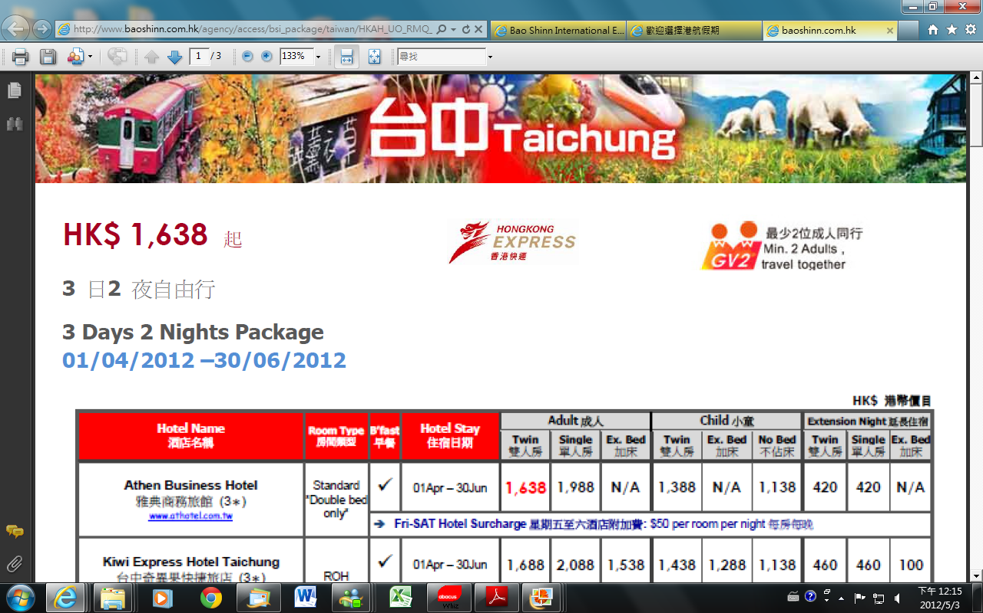
HK$ 1,638起
3日2夜自由行
3 Days 2 Nights Package
01/06/2012 – 30/09/2012

Amazing Offer 驚喜優惠
每位即可減成人$160 /小童$120
出發日期: 01/06/2012 – 30/06/2012
**詳情請參閱P.3機票附加費附表**


HK$ 港幣價目
Hotel Name  酒店名稱 | Room Type  房間類型 | B’fast  早餐 | Hotel Stay  住宿日期 | Adult成人 |  |  | Child小童 |  |  | Extension Night延長住宿
 |  |  |  | Twin  雙人房 | Single  單人房 | Ex. Bed  加床 | Twin  雙人房 | Ex. Bed  加床 | No Bed  不佔床 | Twin  雙人房 | Single  單人房 | Ex. Bed  加床
Athen Business Hotel  雅典商務旅館 (3＊)  www.athotel.com.tw | Standard  *Double bed* | ✓ | 01 Jun – 30 Sep | 1,638 | 1,988 | N/A | 1,438 | N/A | 1,088 | 420 | 420 | N/A
Athen Business Hotel  雅典商務旅館 (3＊)  www.athotel.com.tw | Standard  *Double bed* | - Fri-SAT Hotel Surcharge星期五至六酒店附加費: $50 per room per night每房每晚
Kiwi Express Hotel Taichung  台中奇異果快捷旅店 (3＊)  http://kiwi.hotel.com.tw/ | ROH | ✓ | 01 Jun – 30 Sep | 1,738 | 2,138 | 1,538 | 1,488 | 1,288 | 1,088 | 460 | 460 | 100
 | ROH | - SAT Hotel Surcharge星期六酒店附加費: $60 per room per night每房每晚
Plaza Hotel  達欣‧精品商務飯店 (3＊)  www.plazahotel.com.tw | Warm  (無窗) | ✓ | 01 Jun – 30 Sep | 1,738 | 2,038 | N/A | 1,488 | N/A | 1,088 | 450 | 400 | N/A
Plaza Hotel  達欣‧精品商務飯店 (3＊)  www.plazahotel.com.tw | Warm  (無窗) | - Fri-SAT Hotel Surcharge星期五至六酒店附加費: $60 per room per night每房每晚
Garden Hotel  西苑旅店 (3＊)  www.gardenhotel1971.com | Standard  *Double bed* | ❒ | 01 Jun – 30 Sep | 1,688 | 2,038 | N/A | 1,438 | N/A | 1,088 | 450 | 450 | N/A
The Leparker Hotel  黎客商旅 (3＊)  www.leparker-hotel.com.tw | Standard | ✓ | 01 Jun – 30 Sep | 1,888 | 2,388 | N/A | 1,638 | N/A | 1,088 | 570 | 570 | N/A
The Leparker Hotel  黎客商旅 (3＊)  www.leparker-hotel.com.tw | Standard | - SAT Hotel Surcharge星期六酒店附加費: $230 per room per night每房每晚
EN Vogue Hotel  創意時尚飯店 (3＊)  www.envoguehotel.com | Superior | ✓ | 01 Jun – 30 Sep | 1,838 | 2,288 | 1,588 | 1,588 | 1,338 | 1,088 | 570 | 570 |  | 120
InOne City Inn  文華道會館(4＊)  http://www.inone.com.tw/ | Superior Studio | ✓ | 01 Jun – 30 Sep | 1,888 | 2,488 | N/A | 1,638 | N/A | 1,088 | 630 | 630 | N/A
InOne City Inn  文華道會館(4＊)  http://www.inone.com.tw/ | Superior Studio | - SAT Hotel Surcharge星期六酒店附加費：$80 per room per night每房每晚
Forte Orange Hotel–Taichung Park  福泰桔子商務旅館-公園店 (4＊)  www.forte-hotel.net/index.asp | Deluxe | ✓ | 01 Jun – 30 Sep | 1,888 | 2,338 | 1,538 | 1,638 | 1,288 | 1,088 | 630 | 570 |  | 90

HK$ 港幣價目
Hotel Name  酒店名稱 | Room Type  房間類型 | B’fast  早餐 | Hotel Stay  住宿日期 | Adult成人 |  |  | Child小童 |  |  | Extension Night延長住宿
 |  |  |  | Twin  雙人房 | Single  單人房 | Ex. Bed  加床 | Twin  雙人房 | Ex. Bed  加床 | No Bed  不佔床 | Twin  雙人房 | Single  單人房 | Ex. Bed  加床
Beacon Hotel  碧根行館 (4＊)  http://beacon.hotel.com.tw | Standard | ✓ | 01 Jun – 30 Sep | 1,988 | 2,638 | N/A | 1,738 | N/A | 1,088 | 700 | 700 | N/A
Beacon Hotel  碧根行館 (4＊)  http://beacon.hotel.com.tw | Standard | - SAT Hotel Surcharge星期六酒店附加費：$190 per room per night每房每晚
Holiday Inn Express Taichung Park  台中公園快捷假日酒店 (4＊)  *Extra Bed=Sofa Bed*  www.taichung.hiexpress.com | Standard | ✓ | 01 Jun – 30 Sep | 1,938 | 2,538 | N/A | 1,688 | N/A | 1,088 | 660 | 660 | N/A
 | Standard | - SAT Hotel Surcharge星期六酒店附加費：$110 per room per night每房每晚
The Sun Hot Spring & Resort  台中日光溫泉 (4＊)  http://www.sunhot.com.tw/ | SPA生活館-蜜月房  *Double bed* | ✓ | 01 Jun – 30 Sep | 1,938 | 2,488 | N/A | 1,688 | N/A | 1,088 | 630 | 630 | N/A
 | SPA生活館-蜜月房  *Double bed* | - FRI-SAT & Holiday Eve Hotel Surcharge星期五至六及公眾假期前夕酒店附加費：  $210 per room per night每房每晚
Howard Prince (5*)  台中福華 (5＊)  http://taichung.howard-hotels.com.tw | Superior | ✓ | 01 Jun – 30 Sep | 1,988 | 2,688 | N/A | 1,738 | N/A | 1,088 | 740 | 740 | N/A
 | Superior | - FRI-SAT & Holiday Eve Hotel Surcharge星期五至六及公眾假期前夕酒店附加費：  $90 per room per night每房每晚
52 Hotel  昭盛52 行館 (5＊)  www.smartcue52hotel.com.tw | Standard  *Double bed* | ✓ | 01 Jun – 30 Sep | 2,138 | 2,938 | N/A | 1,888 | N/S | 1,088 | 880 | 880 | N/A
Hung’s Mansion  台中商旅 (4＊)  www.hungsmansion.com | Standard  *Double bed* | ✓ | 01 Jun – 30 Sep | 2,138 | 2,888 | N/A | 1,888 | N/A | 1,088 | 840 | 840 | N/A
Hung’s Mansion  台中商旅 (4＊)  www.hungsmansion.com | Standard  *Double bed* | - SAT Hotel Surcharge星期六酒店附加費：$170 per room per night每房每晚
The Splendor  日華金典酒店 (5＊)  www.splendor-taichung.com.tw | Standard | ✓ | 01 Jun – 30 Sep | 2,188 | 3,038 | N/A | 1,938 | N/A | 1,088 | 890 | 890 | N/A
The Splendor  日華金典酒店 (5＊)  www.splendor-taichung.com.tw | Standard | - SAT Hotel Surcharge星期六酒店附加費：$110 per room per night每房每晚
Tempus Hotel Taichung  永豐棧酒店 (5＊)  www.tempus.com.tw | B館 –  商務客房  *Double bed* | ✓ | 01 Jun – 30 Sep | 2,238 | 3,088 | N/A | 1,988 | N/A | 1,088 | 910 | 910 | N/A
Tempus Hotel Taichung  永豐棧酒店 (5＊)  www.tempus.com.tw | B館 –  商務客房  *Double bed* | - FRI-SAT & Holiday Eve Hotel Surcharge星期五至六及公眾假期前夕酒店附加費：$40 per room per night每房每晚
Hotel One Taichung  台中亞緻大飯店 (5＊)  http://taichung.hotelone.com.twU | Standard | ❒ | 01 Jun – 30 Sep | 2,338 | 3,338 | N/A | 2,088 | N/A | 1,088 | 1,060 | 1,060 | N/A
 | Standard | - SAT Hotel Surcharge星期六酒店附加費：$120 per room per night每房每晚
Windsor Park Hotel  裕元花園酒店 (4＊)  www.windsortaiwan.com | Superior  *Double bed* | ✓ | 01 Jun – 30 Sep | 2,338 | 3,388 | 1,988 | 2,088 | 1,688 | 1,088 | 1,030 | 1,030 | 290
Windsor Park Hotel  裕元花園酒店 (4＊)  www.windsortaiwan.com | Superior  *Double bed* | - SAT Hotel Surcharge星期六酒店附加費：$180 per room per night每房每晚
Freshfields Resort & Conference  清新溫泉渡假酒店 (5＊)  www.freshfields.com.tw/  房間內含泡湯池  酒店有免費巴士由  高鐵至酒店接送(需提前預約) | Superior  *Double bed* | ✓ | 01 Jun – 30 Sep | 2,238 | 3,138 | 2,688 | 1,988 | 2,438 | 1,138 | 980 | 980
 | Superior  *Double bed* | - 01Jun-30Sep: FRI Hotel Surcharge 星期五酒店附加費：$150 per room per night每房每晚  - 01-30Jun & 01-30Sep: SAT Hotel Surcharge星期六酒店附加費：$340 per room per night每房每晚.  - 01Jul-31Aug: SAT Hotel Surcharge星期六酒店附加費：$470 per room per night每房每晚.

per person in HK$ / 每位收費以港幣計算
Departure Dates 出發日期 | Booking Class訂位編號 |  | Flight Restriction航班限制 |  | Ticket Validity機票有效期 | Adult成人 | Child小童
01 Jun 12 – 30 Jun 12 | X (GV2) |  | Any Flight |  | 2 – 7 Days | Less 160 | Less 120
01 Jun 12 – 28 Jun 12  01 Jul 12 – 14 Jul 12  26 Aug 12 – 27 Sep 12 | S (GV2) |  |  |  | 2 – 7 Days | None
01 Jun 12 – 30 Sep 12 | N (GV2) |  |  |  | 2 – 7 Days | 270 | 210
01 Jun 12 – 30 Sep 12 | M (GV2) |  |  |  | 2 – 7 Days | 590 | 450
01 Jun 12 – 30 Sep 12 | K (GV2) |  |  |  | 2 – 7 Days | 800 | 600
01 Jun 12 – 27 Sep 12 | M (GV1) |  | Any Flight |  | 2 – 30 Days | 480 | 360
01 Jun 12 – 30 Sep 12 | L (GV1) |  |  |  | 2 – 30 Days | 800 | 600

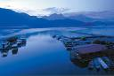
觀光巴士自選1日遊 Optional 1 Day Bus Tour: (2人成行Min. 2 Passengers)
出發時間：約07:30 ~ 08:30 結束時間：約16:30 ~ 17:30
行程選擇(1)：苗粟大湖、飛牛牧場、三義知性
台中→飛牛牧場→風味午餐→三義木雕博物館→參觀鴨箱寶劍(木鴨DIY自費)→勝興車站→台中 ** 費用包括：車資、導覽、風味午餐、保險、飛牛牧場門票、三義木雕博物館門票**行程選擇(2)：談情說畫映日月
台中→向山遊客中心→涵碧樓紀念館→步道漫遊→風味午餐→船遊日月潭（水鳥保護區、拉魯島、玄光寺等）→日月潭商圈巡禮→文武廟→廣興紙寮→台中 ** 費用包括：車資、導覽、保險、日月潭遊船費用、廣興紙寮紙扇體驗 **
每位
HK$470
Package Inclusion: | 套票包括:
- Roundtrip economy class Ticket Hong Kong and Taichung by Hong Kong Express  - 2 nights accommodation with breakfast (Except Specific”x” Hotels)  - Travel Insurance (Coverage of personal accident up to HK$100,000)  - 0.15% TIC Levy | - 香港快運來回香港及台中客位機票乙張  - 2晚酒店住宿包早餐(“x” 指定酒店除外)  - 旅遊保險(人身意外最高賠償HK$100,000)  - 0.15%旅遊業議會印花稅
Terms & Conditions: | 條款及細則:
- Minimum 2 Adults travel together on the same flight throughout the journey.  - Booking must be reserved under the SAME record locator (PNR) for all passengers.  - Child no bed price does not include breakfast  - Child aged under 2 not include insurance.  - Hotel stay must be completed on or before 30 Sep 2012. For hotel stay thereafter, please contact your Travel Agent .  - Flights and room confirmation are subject to availability.  - Package is non-endorsable, non-reroutable and non-refundable.  - Prices quoted are on per person basis and subject to change without prior notice.  - Package Prices inclusive of Hong Kong airport security charge (“Q” charge).  - Departure taxes, airlines insurance surcharge, airlines fuel surcharge and travel agent service fee are not included.  - Reservation must be made at least 3 working days prior to departure.  - For reservation made within 7 working days prior to departure, a non-refundable full payment is required.  - Package are based on Electronic Ticket (E-ticket) only. | - 旅程必須至少兩位成人同時出發及回程.  - 所有同行客人必須於同一PNR內訂位.  - 小童不佔床價格不包括早餐  - 2歲以下小童不包保險.  - 酒店住宿必須於2012年9月30日或之前完成。如有任何查詢，請與您的旅遊顧問.  - 所有預訂須視乎酒店及機位情況方能確定。  - 旅遊套餐在任何情況下都不能更改，轉讓或退還款項。  - 費用均以每人計算，費用如有調整，恕不另行通知。  - 費用已包括香港機場保安稅。  - 費用不包括各地機場離境稅，保險附加費，燃油附加費及旅行社服務費。所有訂位手續須於出發前不少於三個工作天內辦理。  - 凡於出發前7個工作天內辦理預訂手續，須繳付所有款項。  已付之費用概不退還。  - 旅遊套餐只適用於電子機票。

