

- 若茵農場位於台中縣和平鄉，海拔約1000公尺之大雪山深山遊樂區內。房間不設電視，提倡環保亦不設盥洗用品。四季景觀各具風情！
- 春天的油桐花更是如雲似雪！微風徐來，落英繽紛、十分詩情畫意。
- 夏季的蟲鳴鳥叫聲不絕於耳，夜裡的螢火蟲更是精采絕倫。清晨的山嵐及雲瀑一束束的雲瀑從山頭傾瀉而下，令人猶如置身人間仙境。
- 秋夜的星空因為雲量稀少，所以顯得特別的璀璨耀眼，一抬頭，滿天的星海盡入眼簾，可說是觀星的好季節。
- 冬天的雲海則是若茵農場最引以為傲的美景！坐在觀景台上，靄靄白雲連綿繚繞，若茵農場就宛如置身於雲上的城堡，令人有如臨仙境之感。
per person in HK$ / 每位收費以港幣計算
3 Days 2 Nights Package 3日2夜套票
Room Type  房間種類 | B’fast  早餐 | Hotel Stay  住宿日期 | Adult 成人 |  |  | Child 小童 |  |  | Extension Night延長住宿  (Per Room Per Night 每房每晚)
Room Type  房間種類 | B’fast  早餐 | Hotel Stay  住宿日期 | Twin  雙人房 | Single  單人房 | Ex.Bed  加床 | Twin  雙人房 | Ex.Bed  加床 | No Bed  不佔床 | Twin  雙人房 | Single  單人房 | Ex.Bed  加床
雅緻2人房  (竹泉, 山嵐, 晨曦)  *Double Bed only* | ✓ | 01 Jun – 30 Sep | 2,488 | 3,588 | N/A | 2,238 | N/A | 1,138 | 1,170 | 1,170 | N/A
雅緻2人房  (竹泉, 山嵐, 晨曦)  *Double Bed only* | ✓ | - SAT Hotel Surcharge星期六酒店附加費：$350 per room per night每房每晚
VIP 2人房  (讀月, 聽風)  *Double Bed only* | ✓ | 01 Jun – 30 Sep | 2,638 | 3,888 | N/A | 2,388 | N/A | 1,138 | 1,310 | 1,310 | N/A
VIP 2人房  (讀月, 聽風)  *Double Bed only* | ✓ | - SAT Hotel Surcharge星期六酒店附加費：$380 per room per night每房每晚
觀景2人房  (春.不竭, 夏.可遇, 秋.陶然)  * Two Double Bed* | ✓ | 01 Jun – 30 Sep | 4pax  2,038 | 2pax  2,688 | N/A | 4pax  1,788 | N/A | 1,138 | 1,310 | 1,310 | N/A
觀景2人房  (春.不竭, 夏.可遇, 秋.陶然)  * Two Double Bed* | ✓ | - SAT Hotel Surcharge星期六酒店附加費：$380 per room per night每房每晚
若茵農場因『響應環保活動』住房需請客人自備盥洗用品(如: 毛巾, 浴巾, 牙膏, 牙刷等)

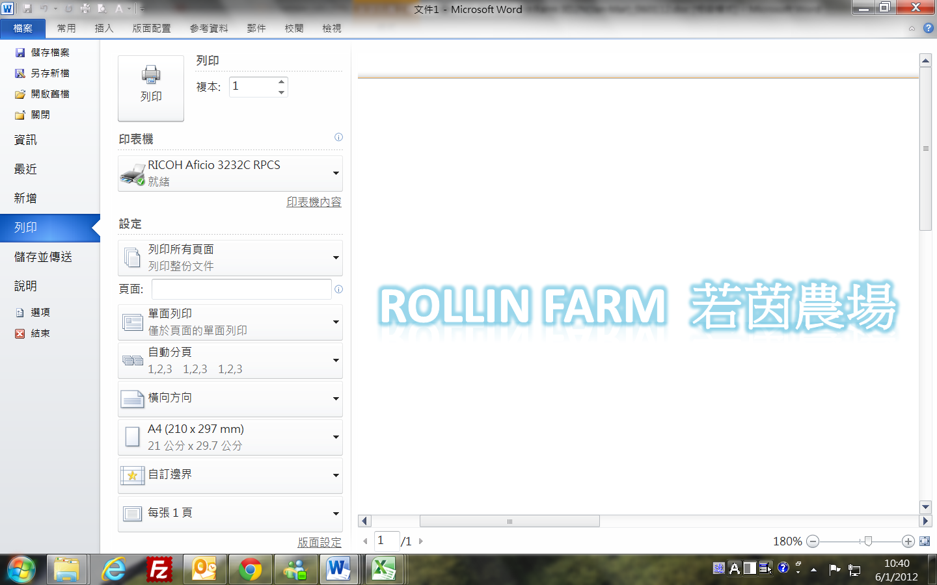
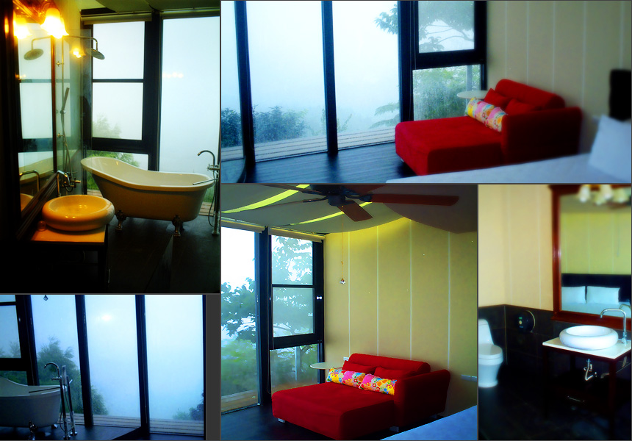
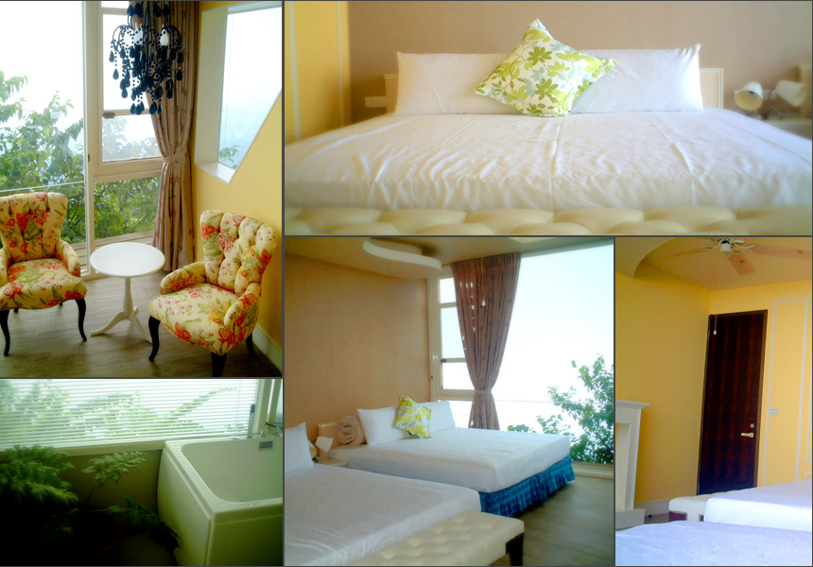
亞緻大飯店
3 Days 2 Nights Package
Valid from 01 Jun 2012 to 30 Sep 2012
www.rollin.com.tw
晨曦、雅緻2人房

春.不竭、觀景2人房
Amazing Offer 驚喜優惠
每位即可減成人$160 /小童$120
出發日期: 01/06/2012 – 30/06/2012
**詳情請參閱P.3機票附加費附表**

Package Inclusion: | 套票包括:
- Roundtrip economy class Ticket Hong Kong and Taichung by Hong Kong Express  - 2 night accommodation in Rollin Farm with breakfast  - Travel Insurance (Coverage of personal accident up to HK$100,000)  - 0.15% TIC Levy | - 香港快運來回香港及台中客位機票乙張  - 2晚若茵農場住宿包早餐  - 旅遊保險(人身意外最高賠償HK$100,000)  - 0.15%旅遊業議會印花稅
Terms & Conditions: | 條款及細則:
- Minimum U2 AdultsU travel together on the same flight throughout the journey.  - Booking must be reserved under the SAME record locator (PNR) for all passengers.  - Child no bed price does not include breakfast  - Child aged under 2 not include insurance  - Hotel stay must be completed on or before 30 Sep 2012. For hotel stay thereafter. please contact your Travel Agent.  - Flights and room confirmation are subject to availability.  - Package is non-endorsable, non-reroutable and non-refundable.  - Prices quoted are on per person basis and subject to change without prior notice.  - Package Prices inclusive of Hong Kong airport security charge (“Q” charge).  - Departure taxes, airlines insurance surcharge, airlines fuel surcharge and travel agent service fee are not included.  - Reservation must be made at least 3 working days prior to departure.  - For reservation made within 7 working days prior to departure, a non-refundable full payment is required.  - Package are based on Electronic Ticket (E-ticket) only. | - 旅程必須至少U兩位成人U同時出發及回程.  - 所有同行客人必須於同一PNR內訂位.  - 小童不佔床價格不包括早餐  - 2歲以下小童不包保險.  - 酒店住宿必須於2012年09月30日或之前完成。如有任何查詢，請與您的旅遊顧問.  - 所有預訂須視乎酒店及機位情況方能確定。  - 旅遊套餐在任何情況下都不能更改，轉讓或退還款項。  - 費用均以每人計算，費用如有調整，恕不另行通知。  - 費用已包括香港機場保安稅。  - 費用不包括各地機場離境稅，保險附加費，燃油附加費及旅行社服務費。  - 所有訂位手續須於出發前不少於三個工作天內辦理。  - 凡於出發前7個工作天內辦理預訂手續，須繳付所有款項。  已付之費用概不退還。  - 旅遊套餐只適用於電子機票。

Optional airport transfer details自選機場接送詳情 (1.5 Hours)
per person in HK$/每位收費以港幣計算 (Min. 2 Pax)
 | Taichung Ching-Chuang-Kang Airport – Rollin Farm  臺中清泉崗機場至若茵農場 | One Way單程 | Round Trip來回雙程
 |  | $350 | $630

per person in HK$ / 每位收費以港幣計算
Departure Dates 出發日期 | Booking Class訂位編號 |  | Flight Restriction航班限制 |  | Ticket Validity機票有效期 | Adult成人 | Child小童
01 Jun 12 – 30 Jun 12 | X (GV2) |  | Any Flight |  | 2 – 7 Days | Less 160 | Less 120
01 Jun 12 – 28 Jun 12  01 Jul 12 – 14 Jul 12  26 Aug 12 – 27 Sep 12 | S (GV2) |  |  |  | 2 – 7 Days | None
01 Jun 12 – 30 Sep 12 | N (GV2) |  |  |  | 2 – 7 Days | 270 | 210
01 Jun 12 – 30 Sep 12 | M (GV2) |  |  |  | 2 – 7 Days | 590 | 450
01 Jun 12 – 30 Sep 12 | K (GV2) |  |  |  | 2 – 7 Days | 800 | 600
01 Jun 12 – 27 Sep 12 | M (GV1) |  | Any Flight |  | 2 – 30 Days | 480 | 360
01 Jun 12 – 30 Sep 12 | L (GV1) |  |  |  | 2 – 30 Days | 800 | 600

