

Room Type 房間種類 | Hotel Stay  酒店住宿 | Adult 成人 |  |  | Child 小童 |  |  | Extension Night with Breakfast  包早餐延長住宿
Room Type 房間種類 | Hotel Stay  酒店住宿 | Twin  雙人房 | Single  單人房 | Ex.Bed  加床 | Twin  雙人房 | Ex.Bed  加床 | No Bed  不佔床 | Twin  雙人房 | Single  單人房 | Ex.Bed  加床
Superior Deluxe  30 sqm, City View | 18 May 12 – 30 Sep 12 | 2588 | 3338 | N/A | 2288 | N/A | 1288 | 1070 | 950 | N/A
Superior Deluxe  30 sqm, City View | 18 May 12 – 30 Sep 12 | - Mon-Thu hotel surcharge星期一至四酒店附加費: $50 per room per night 每房每晚
Superior Deluxe  30 sqm, City View | 01 Oct 12 – 31 Oct 12 | 2738 | 3688 | N/A | 2438 | N/A | 1288 | 1230 | 1150 | N/A
Premium Deluxe  37 sqm, City View | 18 May 12 – 30 Sep 12 | 2738 | 3638 | 2188 | 2438 | 1938 | 1288 | 1230 | 1110 | 290
Premium Deluxe  37 sqm, City View | 18 May 12 – 30 Sep 12 | - Mon-Thu hotel surcharge星期一至四酒店附加費: $50 per room per night 每房每晚
Premium Deluxe  37 sqm, City View | 01 Oct 12 – 31 Oct 12 | 2888 | 4038 | 2188 | 2588 | 1938 | 1288 | 1380 | 1300 | 290
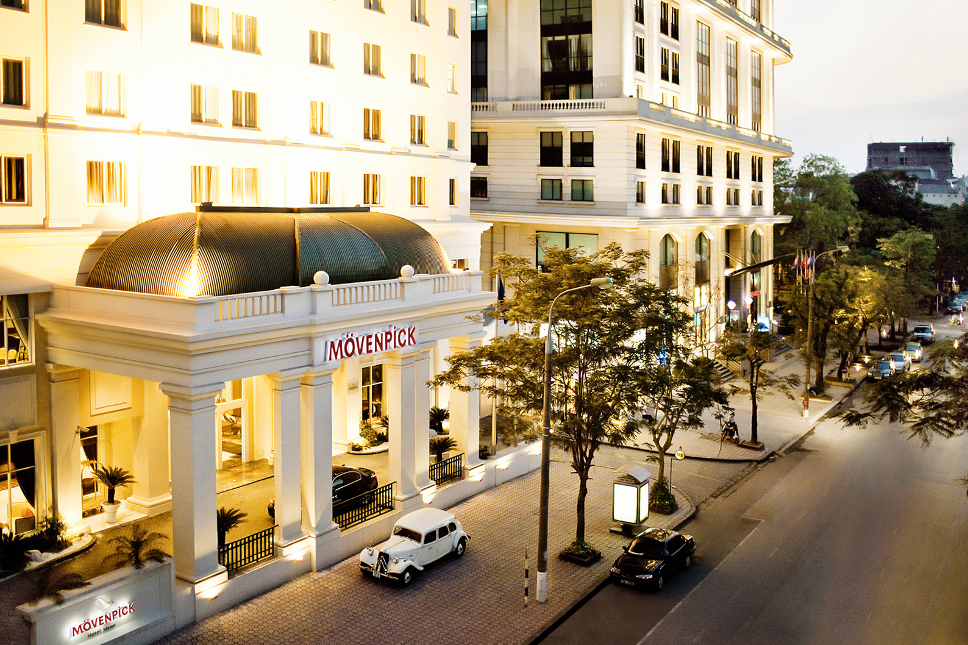
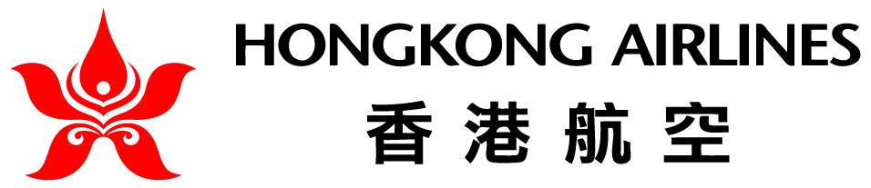

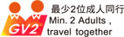
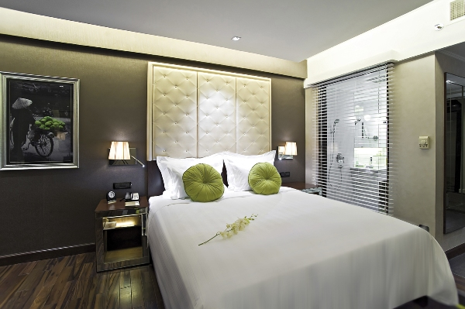

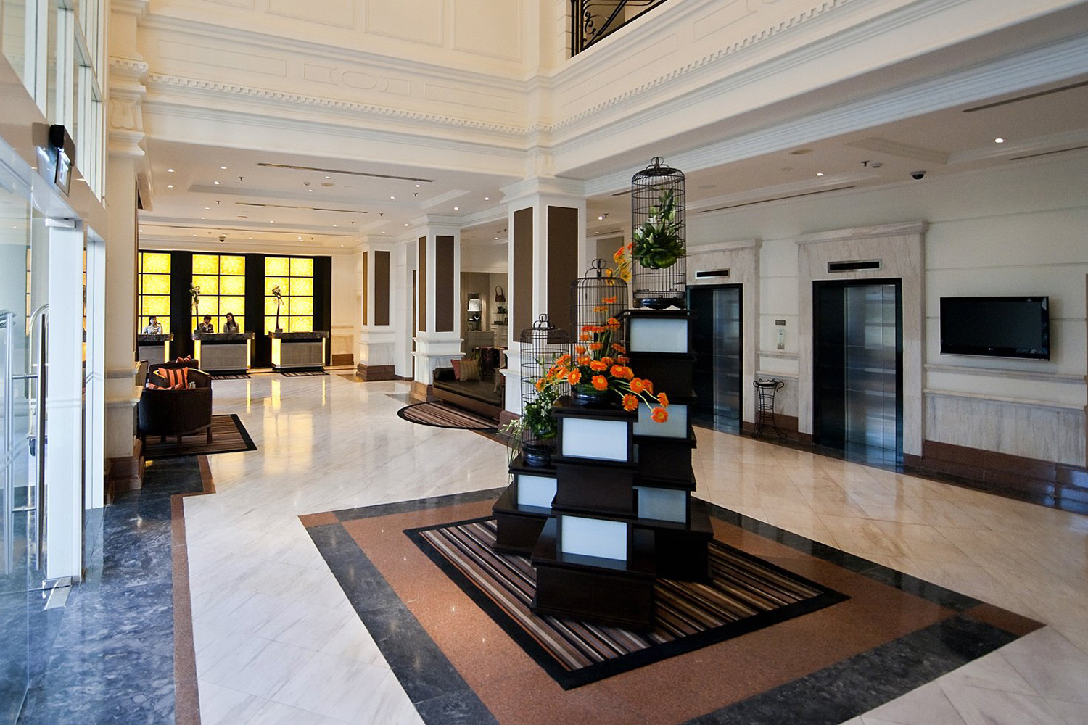
Movenpick Hotel Hanoi
3 Days 2 Nights Package 3日2夜套票
Valid from 18 May till 31 October 2012
www.moevenpick-hotels.com
The Mövenpick Hotel Hanoi is conveniently located in the heart of Hanoi’s central business district. Noi Bai International Airport is a 40-minute drive away and the City Centre 5 minutes.
The hotel features distinctive French architecture with 154 well-appointed rooms and suites. Mangosteen, all-day-dining restaurant offers an interactive buffet-style concept and a creative à la carte menu. Hotel is tailored to meet the needs of discerning corporate and travelers. Hotel also welcome leisure guests wishing to discover the timeless city of Hanoi with its great sights and delights.
Movenpick Hotel Hanoi
3 Days 2 Nights Package
01/04/2012 – 31/10/2012
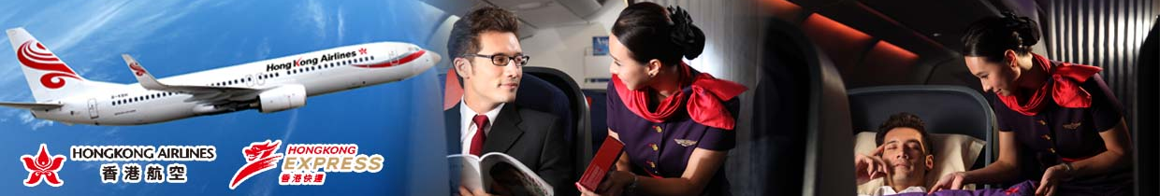
www.moevenpick-hotels.com
Package Inclusion: | 套票包括:
- Roundtrip economy class Ticket Hong Kong and Hanoi by Hong Kong Airlines  - 2 nights accommodation with breakfast  - Travel Insurance (Coverage of personal accident up to HK$100,000)  - 0.15% TIC Levy | - 香港航空來回香港及河內經濟客位機票乙張  - 2晚酒店住宿含早餐  - 旅遊保險(人身意外最高賠償HK$100,000)  - 0.15%旅遊業議會印花稅
Terms & Conditions: | 條款及細則:
- Minimum U2 AdultsU travel together on the same flight throughout the journey.  - Booking must be reserved under the SAME record locator (PNR) for all passengers.  - Child no bed price does not include breakfast  - Child aged under 2 not include insurance.  - Hotel stay must be completed on or before 31 Oct 2012. For hotel stay thereafter, please contact your Travel Agent .  - Flights and room confirmation are subject to availability.  - Package is non-endorsable, non-reroutable and non-refundable.  - Prices quoted are on per person basis and subject to change without prior notice.  - Package Prices inclusive of Hong Kong airport security charge (“Q” charge).  - Departure taxes, airlines insurance surcharge, airlines fuel surcharge and travel agent service fee are not included.  - Reservation must be made at least 3 working days prior to departure.  - For reservation made within 7 working days prior to departure, a non-refundable full payment is required.  - Package are based on Electronic Ticket (E-ticket) only. | - 旅程必須至少U兩位成人U同時出發及回程.  - 所有同行客人必須於同一PNR內訂位.  - 小童不佔床價格不包括早餐  - 2歲以下小童不包保險.  - 酒店住宿必須於2012年10月31日或之前完成。如有任何查詢，請與您的旅遊顧問.  - 所有預訂須視乎酒店及機位情況方能確定。  - 旅遊套餐在任何情況下都不能更改，轉讓或退還款項。  - 費用均以每人計算，費用如有調整，恕不另行通知。  - 費用已包括香港機場保安稅。  - 費用不包括各地機場離境稅，保險附加費，燃油附加費及旅行社服務費。  - 所有訂位手續須於出發前不少於三個工作天內辦理。  - 凡於出發前7個工作天內辦理預訂手續，須繳付所有款項。  已付之費用概不退還。  - 旅遊套餐只適用於電子機票。

Air fare surcharge 機票附加費 |  | per person in HK$ / 每位收費以港幣計算
Departure Dates 出發日期 | Booking Class訂位編號 |  | Ticket Validity機票有效期 | Adult成人 | Child小童
18 May 12 – 30 Jun 12 | X (GV2) |  | 2 – 7 Days | None
18 May 12 – 28 Jun 12  01 Jul 12 – 27 Sep 12  01 Oct 12 – 30 Oct 12 | S (GV2) |  | 2 – 7 Days | 250 | 190
18 May 12 – 30 Oct 12 | N (GV2) |  | 2 – 7 Days | 480 | 360
18 May 12 – 30 Oct 12 | M (GV2) |  | 2 – 7 Days | 800 | 600
18 May 12 – 30 Oct 12 | M (GV1) |  | 2 – 30 Days | 1320 | 990

