Air fare surcharge 機票附加費
Departure Dates .  出發日期 | Booking Class  訂位編號 | Applicable Flight  航班 | Ticket Validity  機票有效期 | Adult  成人 | Child  小童
01Jun -- 28Sep,2012  02Oct -- 31Oct,2012 | T + H (Domestic) | VN595/VN594 | 0-14 Days | None | None
01Jun -- 28Sep,2012  02Oct -- 31Oct,2012 | L + H (Domestic) | VN595/VN594 | 0-14 Days | $300 | $230
29Sep – 01Oct,2012 | H + H (Domestic) | VN595/VN594 | 0-14 Days | $950 | $750
29Sep – 01Oct,2012 | B + H (Domestic) | VN595/VN594 | 0-14 Days | $1,250 | $950

Con Dao Island (昆崙島)
Six Senses Con Dao

4 Days 3Nights Package
01/06/2012 – 31/10/202
Website : www.sixsenses.com

Special Offer : 01 Jun – 31 Oct 2012
Stay 3 pay 2 (2+1) – Six Senses Con Dao
Package Inclusion套票包括:
- Roundtrip economy class Ticket Hong Kong and Con Dao (via SGN) by Vietnam Airways
越南航空來回香港及昆崙島(經胡志明)經濟客位機票乙張
- 3-night accommodation with breakfast 3晚酒店住宿含早餐
- Roundtrip airport transfer between Ho Chi Minh City (Seat in Coach). 機場至胡志明市酒店來回接送
- Roundtrip airport transfer between Con Dao resort. 機場至昆崙島酒店來回接送

- Travel Insurance (Coverage of personal accident up to HK$100,000)
旅遊保險(人身意外最高賠償HK$100,000)
- 0.15% TIC Levy 0.15%旅遊業議會印花

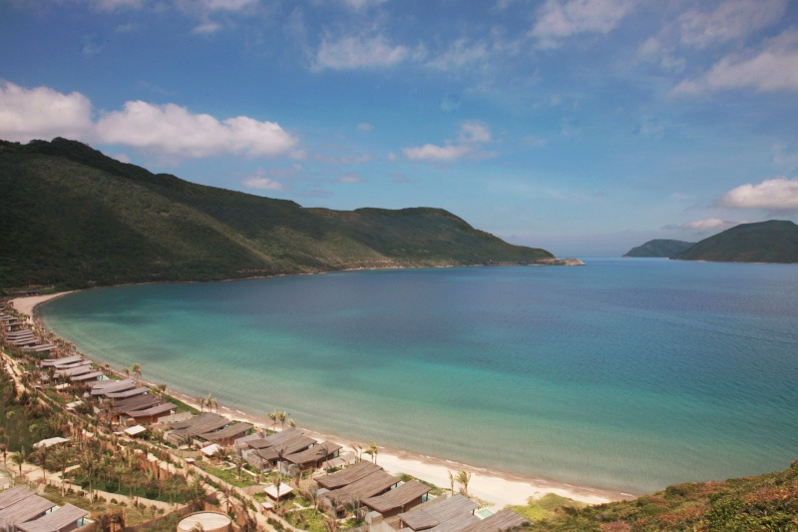
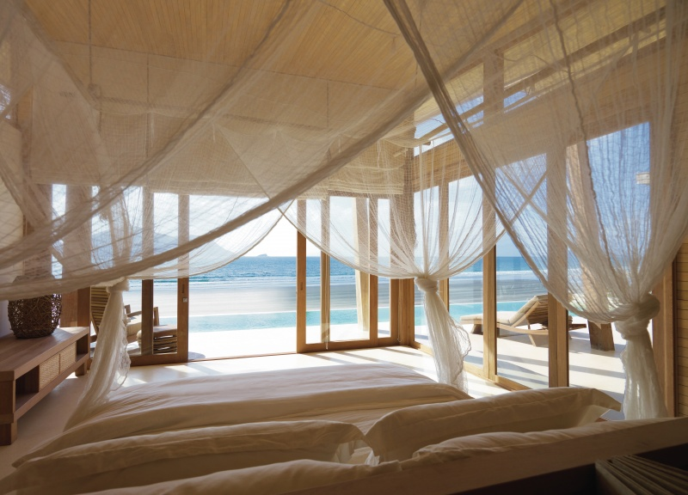
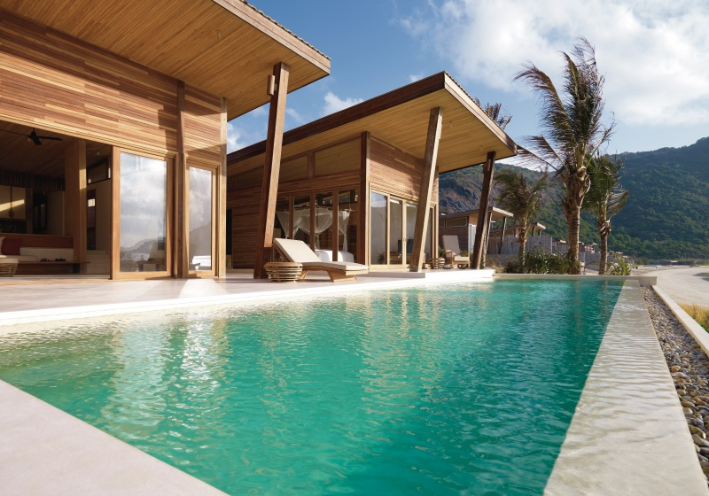
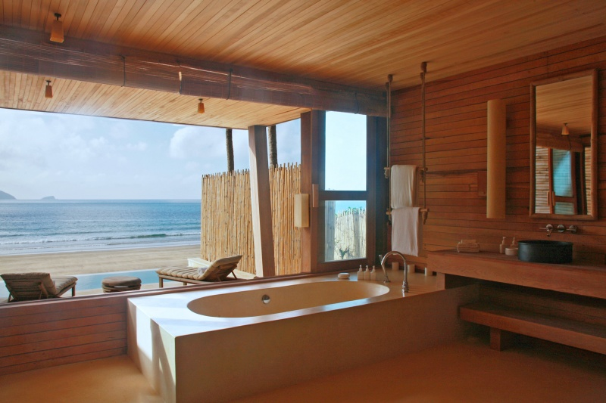
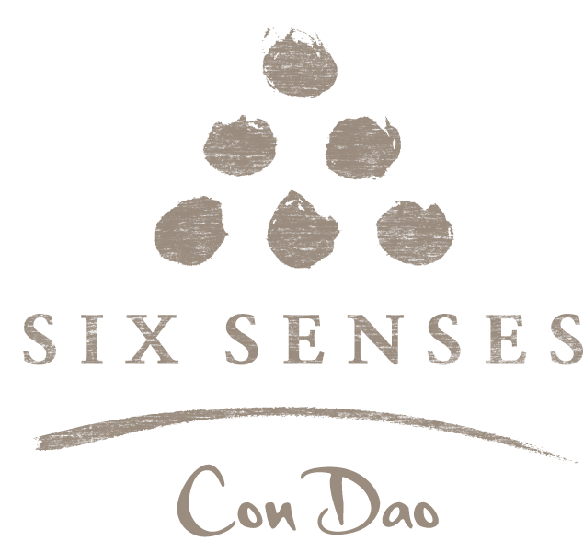
Validity有效日期:01Jun-31Oct2012 |  | per person in HK$ / 每位收費以港幣計算
Hotel | Room Type  房間類別 |  | Adult 成人 |  | Extension Night  延長住宿  (Per Room / Night)
Hotel |  |  | Twin | Single | Extension Night  延長住宿  (Per Room / Night)
(First Night stay at  Ho Chi Minh City)  Sofitel Saigon Plaza  (1night/Superior Room)  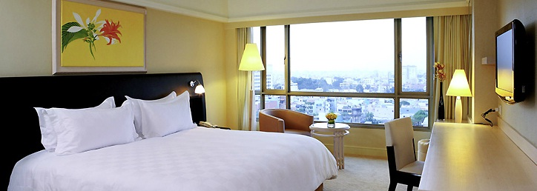  +  (2&3 Night stay at  Con Dao Island)  Six Senses  Con Dao  (2nights) | Ocean View Deluxe Villa  (194sqm) |  | 7,690 | 12,490 | 4000 (Six Senses)  1370 (Sofitel)
 | Ocean Front Villa  (150sqm) |  | 8,190 | 13,490 | 4500 (Six Senses)  1370 (Sofitel)
 | Ocean Front Deluxe Villa  (194sqm) |  | 9,190 | 15,390 | 5500 (Six Senses)  1370 (Sofitel)
 | Ocean View 4 Bedroom Villa  (671sqm) |  | 7,090  (8pax) | 7,690  (7pax) | 13600 (Six Senses)  1370 (Sofitel)
Accommodation Arrangement in Ho Chi Minh City :
~ 8 Pax : 4 twin room
~ 7 Pax : 3 twin room + 1 extra bed

Terms & Conditions 條款及細則:
- Child Price (Share Twin or Extra Bed): Adult Prices Less $450 (Share Twin or Extra Bed)
小童價格 (佔半房或加床): 按成人價格減 $450(佔半房或加床)
- Child NO Bed & NO Breakfast Price $2,890 per person 小童不佔床及不包早餐價錢 每位$2,890。
- Price quoted subject to hotel special seasons surcharge. 酒店如因特別日子需另收附加費,恕不另行通知。
- Hotel stay must be completed on or before 31 Oct 2012. For hotel stay thereafter, please contact our travel consultant. 酒店住宿必須於2012年10月31日或之前完成。如有任何查詢，請與我們的旅遊顧問聯絡。
Hotel rate quoted subject to festival season surcharge 酒店價格或會因為節日而有所不同
- Prices quoted are on per person basis and subject to change without prior notice.
費用均以每人計算，費用如有調整，恕不另行通知。
- Package is non-endorsable, non-reroutable and non-refundable.
旅遊套餐在任何情況下都不能更改，轉讓或退還款項。
- Departure taxes, Hong Kong airport security charge, airlines insurance surcharge, airlines fuel surcharge, travel agent service fee are not included.
費用不包括各地機場離境稅，香港機場保安稅，保險附加費，燃油附加費及旅行社服務費。
- Reservation must be made at least 7 working days prior to departure.
所有訂位手續須於出發前不少於七個工作天內辦理。
- For reservation made within 7 working days prior to departure, a non-refundable full payment is required.
凡於出發前7個工作天內辦理預訂手續，須繳付所有款項, 已付之費用概不退還。

