3

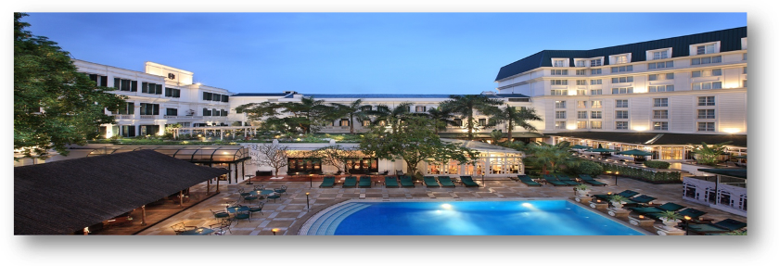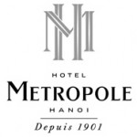he

**Metropole Hotel Hanoi**

**Package Inclusion 套票包括：**－

－Roundtrip economy class Ticket Hong Kong and Hanoi by Vietnam Airlines

越南航空來回香港及河內經濟客位機票乙張

－2-night accommodation with breakfast 2晚酒店住宿含早餐

－Travel insurance (Coverage of person **accident up to HK$100,000**

**旅遊保險（人身意外最高賠償 HK$100,000)**

**－0.15％ TIC Levy 0.15旅遊業議會印花**

3Day 2 Nights Package

31Jul - 31Oct 2012

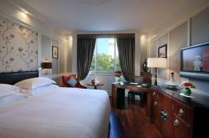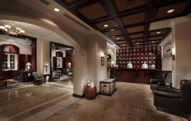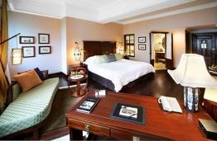

Tour Code: VNHANMTP3D2N-R1

|  |  |  |  |  |  |  |  |  |  |  |  |  |  |  |  |  |  |  |  |  |  |  |  |  |  |  |  |  |  |  |  |
| --- | --- | --- | --- | --- | --- | --- | --- | --- | --- | --- | --- | --- | --- | --- | --- | --- | --- | --- | --- | --- | --- | --- | --- | --- | --- | --- | --- | --- | --- | --- | --- |
| |  |  |  |  |  |  |  | | --- | --- | --- | --- | --- | --- | --- | | Hotel Stay酒店入住日期 : | | | | per person in HK$／  每位收費以港幣計算 | | | | Date  日期 | Room Type房間類別 | Adult 成人 | | | | Extension Night  延長住宿  (Per Room / Night) | | Twin | Single | | Extra  Bed | | 31Jul-30Sep,12 | Grand Luxury -Metropole Wing | 4,250 | 6,350 | | 2,850 | 2,290 | | 01Oct -31Oct,12 | 4,750 | 7,450 | | 2,850 | 2,840 | |

|  |  |  |  |
| --- | --- | --- | --- |
|  | | | |
| Bao Shinn Logo | **Operated by Bao Shinn Int’l Express Ltd. (Licence No. 352614)** | PTS_V4 | **Operated by H.C.Patterson& Co Ltd. (Licence No. 350200)** |
| 🕾 **: 3188 6611** 🖶 **: 3188 6622** | 🕾 **: 3102 2371** 🖶 **: 3102 2380** |
| **Website : www.baoshinn.com.hk** | **Website: www.pattersontravel.com.hk** |
| **E mail : reservation@baoshinn.com.hk** | **E mail: package@pattersontravel.com.hk** |
| Address: Flat A-B, 8/F, No. 8 Hart Avenue, TsimShaTsui, KLN  \*百樂門酒樓樓上\* ( MTR Exit A2, D2 or N1 ) | Address: Flat F, 8/F, No. 8 Hart Avenue, TsimShaTsui, KLN  \*百樂門酒樓樓上\* ( MTR Exit A2, D2 or N1 ) |
| Last Updated: 31Jul 2012 (AC200/EN50) | | Please call for duplicated e-mail or needless, thanks you ! | |

# 

|  |
| --- |
| **Terms & Conditions 條款及細則:**   * **Child Price** (Share Twin or Extra Bed)**: Adult Prices Less $400**(Share Twin or Extra Bed)   **小童價格**(佔半房或加床)**: 按成人價格減 $400**(佔半房或加床)   * **Child NO Bed & NO Breakfast Price $1,400per person 小童不佔床及不包早餐價錢每位$1,400**。 * Price quoted subject to hotel special seasons surcharge. 酒店如因特別日子需另收附加費,恕不另行通知。 * **Hotel stay must be completed on or before 31 Oct2012. For hotel stay thereafter, please contact our travel consultant.酒店住宿必須於2012年10月31日或之前完成。如有任何查詢，請與我們的旅遊顧問聯絡。**   Hotel rate quoted subject to festival season surcharge 酒店價格或會因為節日而有所不同   * Prices quoted are on per person basis and subject to change without prior notice.   費用均以每人計算，費用如有調整，恕不另行通知。   * Package is non-endorsable, non-reroutable and non-refundable.   旅遊套餐在任何情況下都不能更改，轉讓或退還款項。   * Departure taxes, Hong Kong airport security charge, airlines insurance surcharge, airlines fuel surcharge, travel agent service fee are not included.   費用不包括各地機場離境稅，香港機場保安稅，保險附加費，燃油附加費及旅行社服務費。   * Reservation must be made at least 7 working days prior to departure.   所有訂位手續須於出發前不少於七個工作天內辦理。   * For reservation made within 7 working days prior to departure, a non-refundable full payment is required.   凡於出發前7個工作天內辦理預訂手續，須繳付所有款項, 已付之費用概不退還 |

|  |  |  |  |  |  |
| --- | --- | --- | --- | --- | --- |
| **Air fare surcharge 機票附加費** | | |  | | |
| **Departure Dates 出發日期** | **Flight Restriction** | **Booking Class** | **Ticket Validity** | **Adult成人** | **Child小童** |
| **航班限制** | **訂位編號** | **機票有效期** |
| 26Sep,12– 28Sep,12  02Oct,12 – 31Oct,12 | **VN593/VN592** | T |  | None | |
| L | 300 | 230 |
| 29Sep,12 – 01Oct,12 | H | 950 | 230 |
| B | 1250 | 950 |