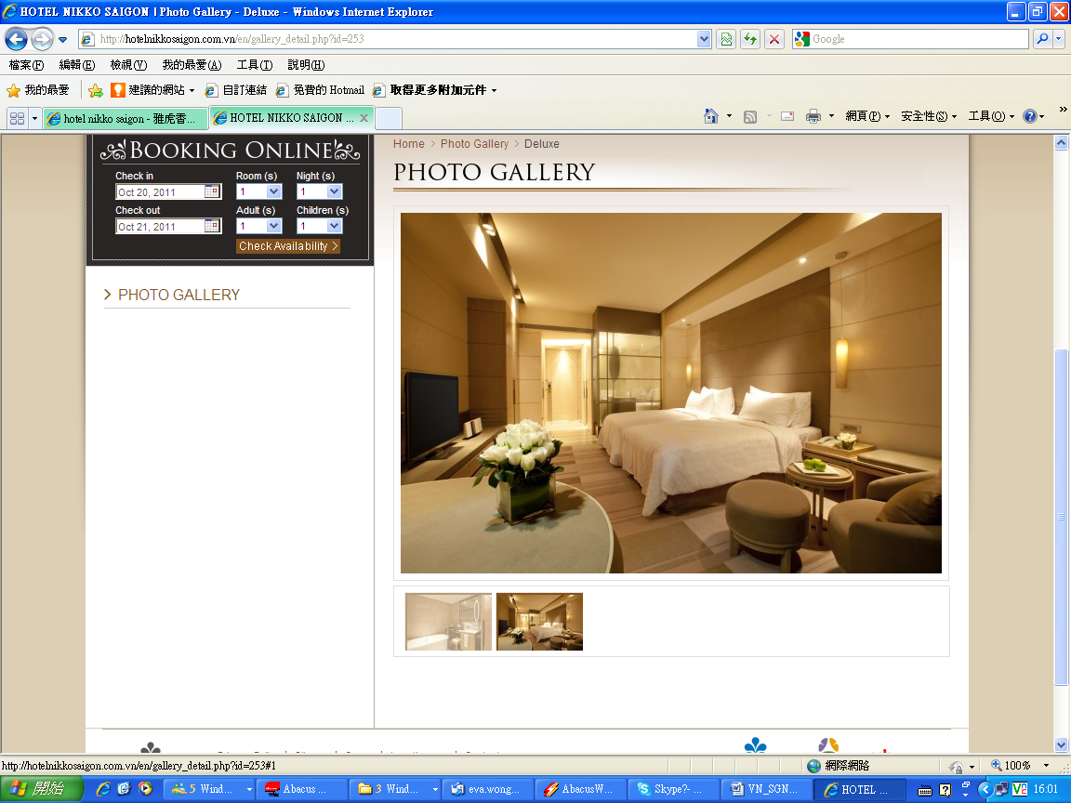
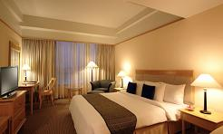
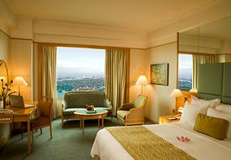
Hotel Name  酒店名稱 | Room Type  房間種類 | Validity  有效日期 | Adult 成人 |  |  | Extension Night  延長住宿
Hotel Name  酒店名稱 | Room Type  房間種類 | Validity  有效日期 | Twin  雙人房 | Single  單人房 | Extra Bed  加床 | Twin / Single  雙人/單人房 | Extra Bed  加床
Windsor Plaza Hotel (4*)  www.windsorplazahotel.com | Deluxe | 01Apr – 30Sep,12 | 2,650 | 3,250 | 2,550 | 750 | 270
Windsor Plaza Hotel (4*)  www.windsorplazahotel.com | Deluxe | 01Oct – 31Oct,12 | 2,750 | 3,350 | 2,550 | 790 | 270
Contiental Hotel (3*)  www.continentalhotel.com.vn/ | Deluxe | 01Apr – 30Sep,12 | 2,750 | 3,550 | 2,550 | 880 | 270
Liberty Central Hotel (4*)  www.libertycentral.org/ | Deluxe | 01Apr – 30Sep,12 | 2,750 | 3,450 | N/A | 830 | N/A
Hotel Equatorial Saigon (4*)  www.equatorial.com/hcm/  *Non Japanese | Deluxe | 01Apr -31Oct,12 | 2,950 | 3,950 | 2,750 | 1,070 | 410
New World Hotel Saigon (5*)  www.newworldvietnam.com/ | Deluxe | 01Apr -31Oct,12 | 2,950 | 3,950 | 2,550 | 1,070 | 300
New World Hotel Saigon (5*)  www.newworldvietnam.com/ | Deluxe | 01Apr -31Oct,12 | Weekday Sun-Thu Surcharge HK$90 per room per night.
Parkroyal Saigon (4*) www.parkroyalhotels.com | Deluxe | 01Apr – 31Oct,12 | 2,950 | 3,850 | 2,650 | 1,050 | 340
Moevenpick Hotel Saigon(4-5*)  www.moevenpick-hotels.com// | Deluxe | 01Apr – 31Oct,12 | 3,050 | 4,050 | 2,650 | 1,110 | 340
Hotel Nikko Saigon (5*)  www.hotelnikkosaigon.com.vn/  New Hotel | Deluxe | 01Apr -30Sep,12 | 3,150 | 4,250 | 2,650 | 1,200 | 340
 | Deluxe | 01Oct – 31Ot,12 | 3,250 | 4,350 | 2,650 | 1,290 | 340
Legend Hotel Saigon (4*) www.legendsaigon.com/  *Non Japanese | Deluxe | 01Apr -30Sep,12 | 3,150 | 4,250 | n/a | 1,240 | Na/
Majestic Saigon (5*)  www.majesticsaigon.com.vn | Colonial City Dlx | 01Apr -30Sep,12 | 3,150 | 4,250 | 2,850 | 1,250 | 420
Majestic Saigon (5*)  www.majesticsaigon.com.vn | Colonial City Dlx | 01Apr -30Sep,12 | 01-30Jun Room Surcharge HK$200 per room per night.
Majestic Saigon (5*)  www.majesticsaigon.com.vn | Colonial City Dlx | 01Oct -31Oct,12 | 3,350 | 4,750 | 2,850 | 1,490 | 420
Renaissance Riverside Hotel (5*)  www.marriott.com  *Non Japanese | Deluxe  Cityview | 01Apr -30Sep,12 | 3,150 | 4,250 | 2,550 | 1,200 | 300
 | Deluxe  Cityview | 01Oct -31Oct,12 | 3,250 | 4,550 | 2,550 | 1,370 | 300
Caraelle Hotel (5*)  www.caravellehotel.com/ | Deluxe | 01Apr -09Apr,12  27Apr – 02Sep,12 | 3,250 | 4,450 | 2,950 | 1,360 | 500
Caraelle Hotel (5*)  www.caravellehotel.com/ | Deluxe | 01Apr -09Apr,12  27Apr – 02Sep,12 | Weekday Mon- Thu Surcharge HK$90 per room per night.
Caraelle Hotel (5*)  www.caravellehotel.com/ | Deluxe | 10Apr – 26Apr,12 | 3,450 | 4,750 | 2,950 | 1,500 | 500
Caraelle Hotel (5*)  www.caravellehotel.com/ | Deluxe | 03Sep – 31Oct,12 | 3,550 | 5,050 | 2,950 | 1,620 | 500
Hotel Nikko Hotel
New World Hotel Saigon
Renaissance Riverside Hotel

Hotel Name  酒店名稱 | Room Type  房間種類 | Validity  有效日期 | Adult 成人 |  |  | Extension Night  延長住宿
Hotel Name  酒店名稱 | Room Type  房間種類 | Validity  有效日期 | Twin  雙人房 | Single  單人房 | Extra Bed  加床 | Twin / Single  雙人/單人房 | Extra Bed  加床
Sheraton Saigon  Hotel & Towers (5*)  www.starwoodhotels.com/sheraton  *Non Japanese | Premier  Deluxe City | 01Apr -31Aug,12 | 3,250 | 4,550 | 2,950 | 1,370 | 480
 | Premier  Deluxe City | 01Sep -31Oct,12 | 3,550 | 4,850 | 2,950 | 1,670 | 480
Sofitel Saigon Plaza (5*)  www.sofitel.com | Superior | 01Apr -31Oct,12 | 3,750 | 5,350 | 2,550 | 1,790 | 300
Park Hyatt (5*)  www.saigon.park.hyatt.com/ | Park Room | 01Apr -30Sep,12 | 6,150 | 10,150 | n/a | 4,190 | n/a
Park Hyatt (5*)  www.saigon.park.hyatt.com/ | Park Room | 01Oct -31Oct,12 | 6,650 | 11,250 | n/a | 4,750 | n/a
Air fare surcharge 機票附加費
Departure Dates .  出發日期 | Booking Class  訂位編號 | Applicable Flight  航班 | Ticket Validity  機票有效期 | Adult  成人 | Child  小童
08Apr -- 28Sep,2012  02Oct -- 31Oct,2012 | T | VN595/VN594 | 0-14 Days | None | None
08Apr -- 28Sep,2012  02Oct -- 31Oct,2012 | L | VN595/VN594 | 0-14 Days | $300 | $230
01Apr – 07Apr,2012  29Sep – 01Oct,2012 | H | VN595/VN594 | 0-14 Days | $950 | $750
01Apr – 07Apr,2012  29Sep – 01Oct,2012 | B | VN595/VN594 | 0-14 Days | $1,250 | $950

Package Inclusion套票包括:
- Roundtrip economy class Ticket Hong Kong and Ho Chi Minh City by Vietnam Airways 越南航空來回香港及胡志明市經濟客位機票乙張
- 2-night accommodation with breakfast 2晚酒店住宿含早餐
- Travel Insurance (Coverage of personal accident up to HK$100,000) 旅遊保險(人身意外最高賠償HK$100,000)
- 0.3% TIC Levy 0.3%旅遊業議會印花
Terms & Conditions 條款及細則:
- Child Price (Share Twin or Extra Bed): Adult Prices Less $400 (Share Twin or Extra Bed)
小童價格 (佔半房或加床): 按成人價格減 $400(佔半房或加床)
- Child NO Bed & NO Breakfast Price $1,400 per person 小童不佔床及不包早餐價錢 每位$1,400。
- Price quoted subject to hotel special seasons surcharge. 酒店如因特別日子需另收附加費,恕不另行通知。
- Hotel stay must be completed on or before 31Oct2012. For hotel stay thereafter, please contact our travel consultant.
酒店住宿必須於2012年 10月31日或之前完成。如有任何查詢，請與我們的旅遊顧問聯絡。
Hotel rate quoted subject to festival season surcharge 酒店價格或會因為節日而有所不同
- Prices quoted are on per person basis and subject to change without prior notice. 費用均以每人計算，費用如有調整，恕不另行通知。
- Flights and room confirmation are subject to availability. 所有預訂須視乎酒店及機位情況方能確定。
- Package is non-endorsable, non-reroutable and non-refundable. 旅遊套餐在任何情況下都不能更改，轉讓或退還款項。
- Departure taxes, Hong Kong airport security charge, airlines insurance surcharge, airlines fuel surcharge, travel agent service fee are not included.
費用不包括各地機場離境稅，香港機場保安稅，保險附加費，燃油附加費及旅行社服務費。
- Reservation must be made at least 7 working days prior to departure.
所有訂位手續須於出發前不少於七個工作天內辦理。
- For reservation made within 7 working days prior to departure, a non-refundable full payment is required.
凡於出發前7個工作天內辦理預訂手續，須繳付所有款項, 已付之費用概不退還。

