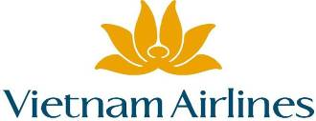
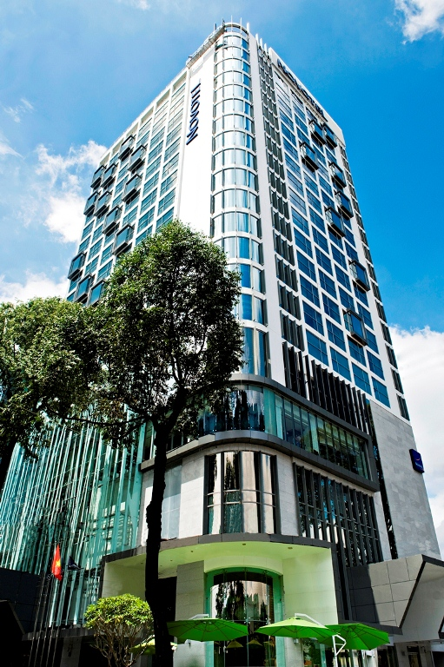
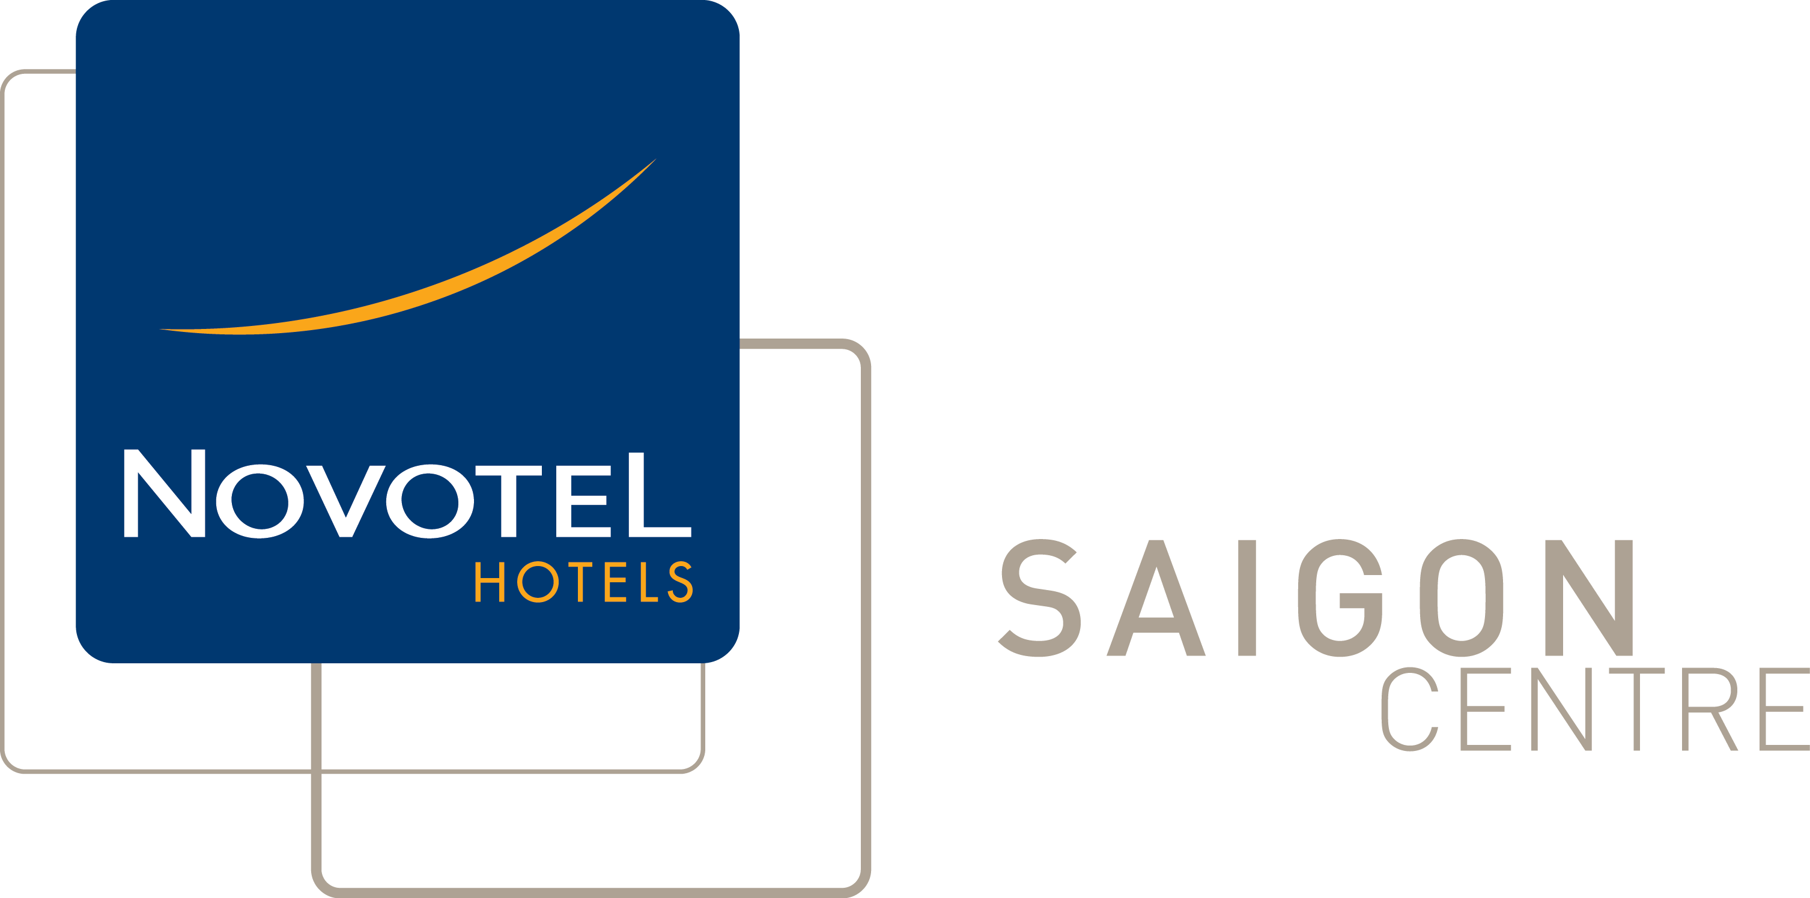
Air fare surcharge 機票附加費
Departure Dates .  出發日期 | Booking Class  訂位編號 | Applicable Flight  航班 | Ticket Validity  機票有效期 | Adult  成人 | Child  小童
01Sep -- 28Sep,2012  02Oct -- 31Oct,2012 | T | VN595/VN594 | 0-14 Days | None | None
01Sep -- 28Sep,2012  02Oct -- 31Oct,2012 | L | VN595/VN594 | 0-14 Days | $300 | $230
29Sep – 01Oct,2012 | H | VN595/VN594 | 0-14 Days | $950 | $750
29Sep – 01Oct,2012 | B | VN595/VN594 | 0-14 Days | $1,250 | $950

Novotel Saigon Centre

3 Days 2 Nights Package

01/09/2012 – 31/10/2012
Website : www.novotel-saigon-centre.com

Package Inclusion套票包括:
- Roundtrip economy class Ticket Hong Kong and Ho Chi Minh City on Vietnam Airways
越南航空來回香港及胡志明經濟客位機票乙張
- 2-night accommodation with breakfast 2晚酒店住宿含早餐
- Travel Insurance (Coverage of personal accident up to HK$100,000)
旅遊保險(人身意外最高賠償HK$100,000)
- 0.15% TIC Levy 0.15%旅遊業議會印花

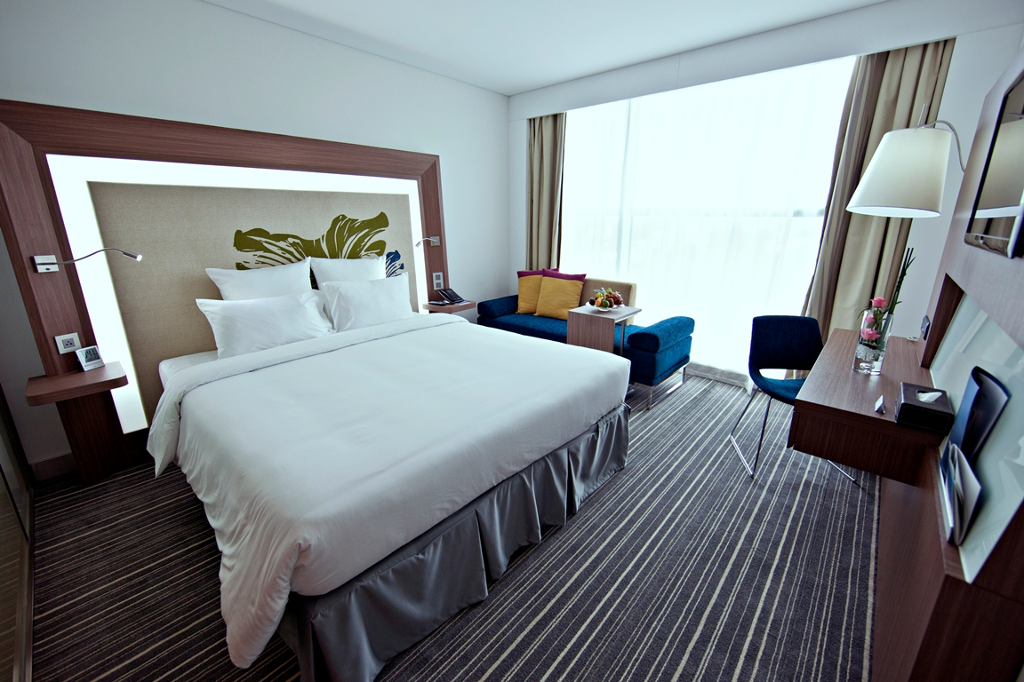
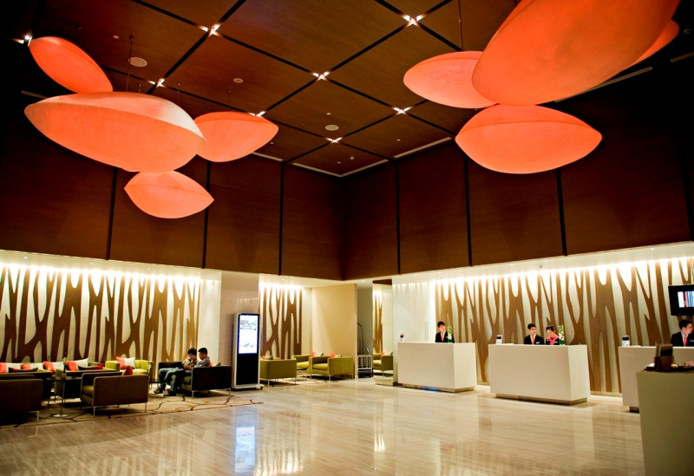
 |  |  | per person in HK$ / 每位收費以港幣計算
Room Type  房間類別 | Validity  有效日期 | Adult 成人 |  |  | Extension Night  延長住宿  (Per Room / Night)
Room Type  房間類別 | Validity  有效日期 | Twin |  | Single | Extension Night  延長住宿  (Per Room / Night)
Superior Room | 01Sep-30Sep2012 | 2890 |  | 3790 | 1020
Superior Room | 01Oct-31Oct2012 | 3090 |  | 4090 | 1140
Deluxe Room | 01Sep-30Sep2012 | 3090 |  | 4090 | 1170
Deluxe Room | 01Oct-31Oct2012 | 3290 |  | 4390 | 1280
Executive Room | 01Sep-30Sep2012 | 3190 |  | 4390 | 1320
Executive Room | 01Oct-31Oct2012 | 3390 |  | 4690 | 1430
Executive Suite | 01Sep-30Sep2012 | 3590 |  | 5090 | 1690
Executive Suite | 01Oct-31Oct2012 | 3790 |  | 5490 | 1800

Terms & Conditions 條款及細則:
- Child Price (Share Twin or Extra Bed): Adult Prices Less $400 (Share Twin or Extra Bed)
小童價格 (佔半房或加床): 按成人價格減 $400(佔半房或加床)
- Child NO Bed & NO Breakfast Price $1,690 per person 小童不佔床及不包早餐價錢 每位$1,690。
- Price quoted subject to hotel special seasons surcharge. 酒店如因特別日子需另收附加費,恕不另行通知。
- Hotel stay must be completed on or before 31 Oct 2012. For hotel stay thereafter, please contact our travel consultant. 酒店住宿必須於2012年10月31日或之前完成。如有任何查詢，請與我們的旅遊顧問聯絡。
Hotel rate quoted subject to festival season surcharge 酒店價格或會因為節日而有所不同
- Prices quoted are on per person basis and subject to change without prior notice.
費用均以每人計算，費用如有調整，恕不另行通知。
- Package is non-endorsable, non-reroutable and non-refundable.
旅遊套餐在任何情況下都不能更改，轉讓或退還款項。
- Departure taxes, Hong Kong airport security charge, airlines insurance surcharge, airlines fuel surcharge, travel agent service fee are not included.
費用不包括各地機場離境稅，香港機場保安稅，保險附加費，燃油附加費及旅行社服務費。
- Reservation must be made at least 7 working days prior to departure.
所有訂位手續須於出發前不少於七個工作天內辦理。
- For reservation made within 7 working days prior to departure, a non-refundable full payment is required.
凡於出發前7個工作天內辦理預訂手續，須繳付所有款項, 已付之費用概不退還。

