VN NEW logo

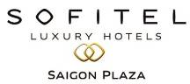

3 Day 2 Nights Package

22/05/ 2012 – 31/10/2012

ttt

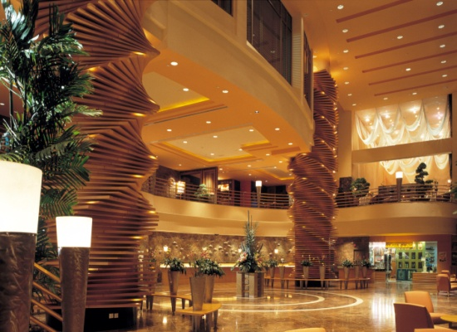

**Package Inclusion 套票包括:**

-Roundtrip economy class Ticket Hong Kong and Ho Chi Minh City by Vietnam airlines

越南航空來回香港及胡志明市經濟客位機票乙張

-2 night accommodation with breakfast 2晚酒店住宿含早餐

-Travel insurance ( Coverage of personal accident up to HK$100,000

旅遊保險 ( 人身意外最高賠償HK$100,000)

-0.15 % TIC Levy 0.15 旅遊業議會印花

|  |  |  |  |  |  |
| --- | --- | --- | --- | --- | --- |
| Hotel Stay酒店入住日期 : 22/05/12-31/10/12 | | | per person in HK$／ | | |
| 每位收費以港幣計算 | | |
| Room Type  房間類別 | Adult 成人 | | | | Extension Night 延長住宿 (Per Room / Night) |
|
| Twin | Single | | Extra bed |
|  |
| Superior Room | 3,250 | 4,550 | | 2550 | 1,370 |

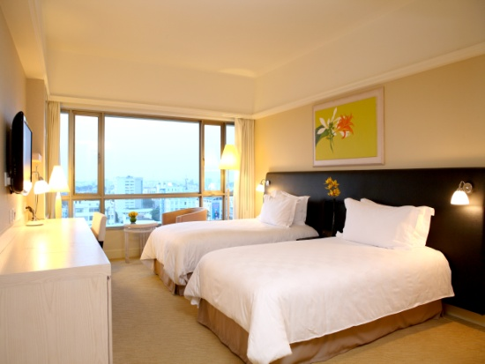

**Terms & Conditions 條款及細則:**

**- Child Price** (Share Twin or Extra Bed)**: Adult Prices Less $400**(Share Twin or Extra Bed)

**小童價格**(佔半房或加床)**: 按成人價格減 $400**(佔半房或加床)

**-Child NO Bed & NO Breakfast Price $1,400per person 小童不佔床及不包早餐價錢每位$1,400**

- Price quoted subject to hotel special seasons surcharge. 酒店如因特別日子需另收附加費,恕不另行通知

- **Hotel stay must be completed on or before 31 Oct2012. For hotel stay thereafter, please contact our travel consultant**

**-酒店住宿必須於2012年10月31日或之前完成。如有任何查詢，請與我們的旅遊顧問聯絡**

Hotel rate quoted subject to festival season surcharge 酒店價格或會因為節日而有所不同

- Prices quoted are on per person basis and subject to change without prior notice

費用均以每人計算，費用如有調整，恕不另行通知

- Package is non-endorsable, non-reroutable and non-refundable

旅遊套餐在任何情況下都不能更改，轉讓或退還款項

- Departure taxes, Hong Kong airport security charge, airlines insurance surcharge, airlines fuel surcharge, travel agent service fee are not included

費用不包括各地機場離境稅，香港機場保安稅，保險附加費，燃油附加費及旅行社服務費

- Reservation must be made at least 7 working days prior to departure

所有訂位手續須於出發前不少於七個工作天內辦理

- For reservation made within 7 working days prior to departure, a non-refundable full payment is required

凡於出發前7個工作天內辦理預訂手續，須繳付所有款項, 已付之費用概不退還

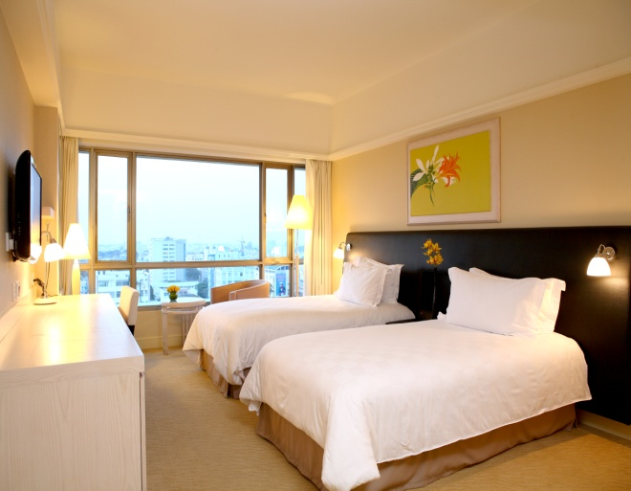

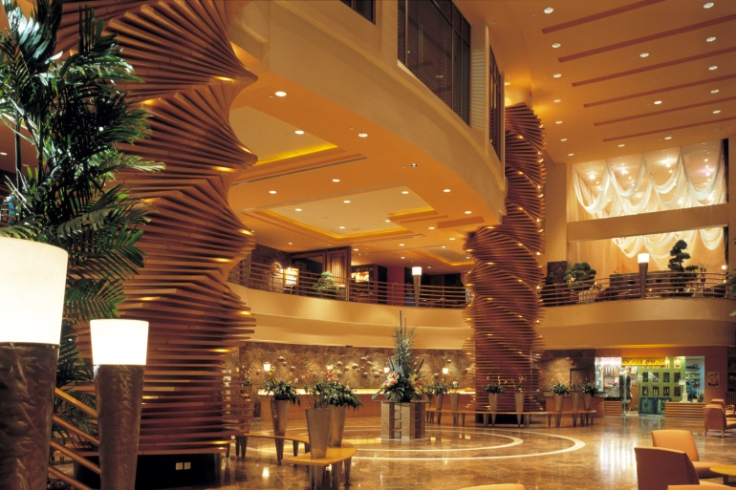

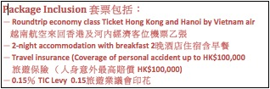

|  |  |  |  |
| --- | --- | --- | --- |
|  | | | |
| Bao Shinn Logo | **Operated by Bao Shinn Int’l Express Ltd. (Licence No. 352614)** | PTS_V4 | **Operated by H.C.Patterson& Co Ltd. (Licence No. 350200)** |
| 🕾 **: 3188 6611** 🖶 **: 3188 6622** | 🕾 **: 3102 2371** 🖶 **: 3102 2380** |
| **Website : www.baoshinn.com.hk** | **Website: www.pattersontravel.com.hk** |
| **E mail : reservation@baoshinn.com.hk** | **E mail: package@pattersontravel.com.hk** |
| Address: Flat A-B, 8/F, No. 8 Hart Avenue, TsimShaTsui, KLN  \*百樂門酒樓樓上\* ( MTR Exit A2, D2 or N1 ) | Address: Flat F, 8/F, No. 8 Hart Avenue, TsimShaTsui, KLN  \*百樂門酒樓樓上\* ( MTR Exit A2, D2 or N1 ) |
| Last Updated: 31 May 2012 (AC200/EN50) | | Please call for duplicated e-mail or needless, thanks you ! | |

|  |  |  |  |  |  |  |
| --- | --- | --- | --- | --- | --- | --- |
| **Air fare surcharge 機票附加費** | | | per person in HK$ / 每位收費以港幣計算 | | | |
| **Departure Dates 出發日期** | **Flight Restriction**  **航班限制** | **Booking Class**  **訂位編號** | | **Ticket Validity**  **機票有效期** | **Adult成人** | **Child小童** |
| 22May,12 – 15Jun,12  05Sep,12 – 25Sep,12  **(The final ticketing date is 31st July)** | **VN595/VN594** | **E** | | 0 – 14Days | **Less 200** | **Less 200** |
| 26Sep,12– 28Sep,12  02Oct,12 – 31Oct,12 | **T** | | None | |
| **L** | | 300 | 230 |
| 29Sep,12 – 01Oct,12 | **H** | | 950 | 750 |
| **B** | | 1,250 | 950 |

Tour Code: VN SGN SOP3D2N